NUMERICAL CONTROLS
of Milling
900 Series

User’s manual

721 P 431

September 2010 Edition
Rev. 0.0


E.C.S. Sistemi Elettronici S.p.A.
Via di Pratignone 15/5 - I - 50019 SESTO FIORENTINO - FIRENZE

INDEX OF REVISION OF THE CHAPTERS
SUBJECT | CURRENT EDITION  REV. 0.0 |  | N° PAGES
SUBJECT | Situation | Date | N° PAGES

TABLE OF REVISIONS
Rev. N. | Description |  | Edition Date
Issued by |  | (signature)
Approved by R&S |  | (signature)

Summary
1 Notes for Consultation 1-11
2 Interface 2-12
2.1 Main Menu 2-12
2.2 MU Environment 2-13
2.2.1 Visualization of the quotas 2-14
2.2.1.1 Selection window axes to be displayed 2-15
2.2.1.2 Selection of the axes displayed by PLC 2-15
2.2.1.3 Display of the quotas in small format 2-15
2.2.1.4 Display of the “Distance To Go” 2-16
2.2.1.5 Display of the “Error” value 2-16
2.2.1.6 Display of the “Actual” quota 2-17
2.2.1.7 Display of the “SA Counts” 2-17
2.2.1.8 Display of the “Axis Status” information 2-17
2.2.1.9 Display of the “Run Stop” information 2-18
2.2.1.10 Display of the status icons of the individual axes 2-18
2.2.2 Graphic display of the processing in real time (RTG) 2-19
2.2.2.1 Buttons Menu 2-19
2.2.2.1.1 “Views” Button 2-20
2.2.2.1.2 “All” Button 2-21
2.2.2.1.3 “Size” Button 2-21
2.2.2.1.4 “Tool” Button 2-21
2.2.2.1.5 “BigWin” Button 2-22
2.2.3 Command String 2-23
2.2.4 Area for inserting Manual Commands (MDI) 2-23
2.2.5 Selection axes to be reset (SetAxes) 2-25
2.2.6 Display Active CNC Mode 2-26
2.2.6.1 CNC Mode Selection 2-27
2.2.6.2 CNC Submode Selection 2-28
2.2.6.3 JOG Submodes Selection 2-29
2.2.6.4 Setting the step value of the JOG 2-30
2.2.6.5 Setting of the JOG with Handwheel 2-31
2.2.6.6 Setting of the Step value for the JOG with Handwheel 2-31
2.2.6.7 Selection Real Time Graphics (RTG) 2-32
2.2.7 Processing parameter display 2-33
2.2.7.1 Active Origin 2-33
2.2.7.2 Last Gxx function programmed display 2-35
2.2.7.3 Last Mxx function programmed display 2-36
2.2.7.4 Tool code set display 2-37
2.2.8 Name of the selected Part Program display 2-41
2.2.9 Display of the line number being executed 2-41
2.2.9.1 Display of the speed of processing 2-43
2.3 PLC Environment 2-44
2.3.1 LOG (PLC LOGIC ENVIRONMENT) 2-45
2.3.1.1 Selections “Next/Previous Variable Type” 2-46
2.3.1.2 Selection “Keys for PLC Window/Keys for Variables Window” 2-46
2.3.1.3 Selection “Edit” 2-46
2.3.1.3.1 Skip to line N. 2-46
2.3.1.3.2 String search 2-46
2.3.1.3.3 Repeat String search 2-46
2.3.1.3.4 Open second File 2-47
2.3.1.3.5 Switch File 2-47
2.3.1.3.6 Close Second File 2-47
2.3.1.4 Selection “CNC/PLC Variables” 2-47
2.3.1.5 Selection “Search for Synonyms” 2-47
2.3.1.6 Selection “Display Synonyms Status” 2-47
2.3.1.7 Selection “Variables List Management” 2-47
2.3.1.8 Selection “Logical Analyser” 2-47
2.3.1.9 Selection “Exit” 2-48
2.3.2 DBG (DEBUG PLC ENVIRONMENT) 2-48
2.3.2.1 Display of the PLC Variables 2-48
2.3.2.2 Selection “CNC/PLC Variables” 2-48
2.3.2.3 Selection “Select Type of Variables” 2-48
2.3.2.4 Selection “Next/Prev. Type of Var.” 2-50
2.3.2.5 Selection “Next/Previous Variable” 2-50
2.3.2.6 Selection “Search for Synonym” 2-50
2.3.2.7 Selection “Variables List Management” 2-50
2.3.2.7.1 Modify Variables List 2-50
2.3.2.7.2 Save Variables List 2-51
2.3.2.7.3 Load Variables List 2-51
2.3.2.7.4 New Variables List 2-51
2.3.2.7.5 Delete Variables List 2-52
2.3.2.7.6 Define Values to be forced 2-52
2.3.2.7.7 Enable Variables “Forcing” 2-52
2.3.2.7.8 Disable Variables “Forcing” 2-53
2.3.2.7.9 Selection “Exit” 2-53
2.3.2.8 Display of the CNC Variables 2-53
2.3.2.8.1 Selection “Select Type of Variables” 2-53
2.3.2.8.2 Selections “Next/Previous Variable Type” 2-55
2.3.2.8.3 Selections “Next/Previous Variable” 2-55
2.3.2.8.4 Selection “CNC/PLC Variables” 2-55
2.3.2.8.5 Selection “Details” 2-55
2.3.2.8.6 Selection “V Variables Mngt” 2-55
2.3.2.8.7 Selection “Exit” 2-55
2.3.3 OSC (Oscilloscope) 2-56
2.3.4 IDE 2-56
2.3.4.1 Selection “Modify/Create PLC Files” 2-56
2.3.4.1.1 The Editing Window 2-57
2.3.4.1.2 Selection “Synonyms Text in Italian/English” 2-58
2.3.4.1.3 Selection “Synonyms into the Line” 2-58
2.3.4.1.4 Selection “List All Synonyms” 2-58
2.3.4.1.5 Selection “Synonyms by Argument” 2-58
2.3.4.1.6 Selection “Edit” 2-59
2.3.4.1.6.1 Skip to line N. 2-59
2.3.4.1.6.2 String Search 2-59
2.3.4.1.6.3 Repeat String Search 2-59
2.3.4.1.6.4 Replace String 2-59
2.3.4.1.6.5 Copy 2-60
2.3.4.1.6.6 Cut 2-60
2.3.4.1.6.7 Paste 2-60
2.3.4.1.6.8 Open second File 2-60
2.3.4.1.6.9 Switch File 2-60
2.3.4.1.6.10 Close Second File 2-60
2.3.4.1.7 Selection “Operations on File” 2-60
2.3.4.1.7.1 Save Changes Made 2-61
2.3.4.1.7.2 Save Buffer on File 2-61
2.3.4.1.7.3 Insert Content of a File 2-61
2.3.4.1.8 Selection “Help” 2-61
2.3.4.1.9 Selection “Exit” 2-61
2.3.4.2 The selection “Construct PLC” 2-61
2.3.4.3 Selection “Cross Reference” 2-62
FIG. 6.4 Editor Help window 1
2.3.4.4 Selection “List PLC Files” 2-63
2.3.4.5 Selection “Options” 2-64
2.3.4.6 Selection “Services” 2-64
2.3.4.7 Selection “PLC Menu” 2-64
2.3.4.8 Selection “Create Ethercat headings” 2-65
2.3.4.9 Selection “Exit” 2-65
2.3.5 ALT EXE 2-65
2.3.6 AZZ NAV 2-65
2.4 PRG Environment 2-66
2.4.1 EDIT PP 2-66
2.4.1.1 Selection of the File to be edited 2-66
FIG. 5-1 Data Entry: “Selection File in Editing” 1
2.4.1.2 The Editing Window 2-67
2.4.1.3 Selection “Fixed Cycles” 2-68
FIG. 5-2 Data Entry associated to fixed cycle(G184) FISSO 1
2.4.1.4 The “Macro selection” 2-70
2.4.1.5 Selection “Geometric Help” 2-73
2.4.1.5.1 Definition of a “Point” 2-74
FIG. 5-3 1
Example of Data Entry associated with the Macro “FORFLA” 1
2.4.1.5.2 Definition of a “Line” 2-74
2.4.1.5.3 Definition of a “Circle” 2-75
2.4.1.5.4 Set Bevel 2-76
2.4.1.5.5 Set Connection 2-76
2.4.1.5.6 Setting Graphic Limits 2-76
2.4.1.5.7 Suggestions for a correct use of the Geometric Help 2-77
2.4.1.6 Selection “Editing Commands” 2-79
2.4.1.6.1 Skip to line N. 2-79
2.4.1.6.2 Search String 2-79
2.4.1.6.3 Repeat Search String 2-79
2.4.1.6.4 Replace String 2-79
2.4.1.6.5 Copy 2-80
2.4.1.6.6 Cut 2-80
2.4.1.6.7 Paste 2-80
2.4.1.6.8 Open second File 2-80
2.4.1.6.9 Switch File 2-80
2.4.1.6.10 Close File 2-80
2.4.1.7 Selection “Operations on File” 2-80
2.4.1.7.1 Save Changes Made 2-80
2.4.1.7.2 Save Buffer on File 2-81
2.4.1.7.3 Insert Content of a File 2-81
2.4.1.7.4 Activate Automatic Numbering 2-81
2.4.1.7.5 Renumbering Part Program 2-81
2.4.1.7.6 Access “MANUALE.FIL” File 2-81
FIG.5-12 1
2.4.1.7.7 Print File 2-82
2.4.1.7.8 Display Tools Table 2-82
2.4.1.7.9 Display Origins Table 2-82
2.4.1.7.10 Selection “Edit Help” 2-82
2.4.1.8 Selection “Code & Show” 2-82
FIG. 5-13 1
Editor Help Window 1
2.4.1.9 Selection “Code & Show Commands” 2-83
2.4.1.9.1 Continuous/Single Execution 2-84
2.4.1.9.2 Select Variables 2-84
2.4.1.9.3 Display Variables 2-84
2.4.1.9.4 Management Tools 2-84
2.4.1.9.5 Management Origins 2-84
2.4.1.9.6 Selection Views 2-85
2.4.1.9.7 Enable/Disable Code & Show 2-85
2.4.1.9.8 Set Graphic Limits 2-85
2.4.1.9.9 Search Graphics 2-85
2.4.1.9.10 Cancel Screen 2-85
2.4.1.10 Selection “Switch Format” 2-85
2.4.1.11 Selection “Exit Editor” 2-86
2.4.1.12 Management Tools in Code & Show / Graphics Environment 2-86
2.4.1.12.1 Insert Tool 2-87
FIG. 5-16 1
Table “Selection Colour Tool” 1
2.4.1.12.2 Insert Corrector 2-89
2.4.1.12.3 Change Tool/Corrector 2-89
2.4.1.12.4 Save Tools Table 2-91
2.4.1.12.5 Load Tools Table 2-91
2.4.1.12.6 Load CNC Tools 2-92
FIG. 5-20 Data Entry: “Save Table Tools” 1
FIG. 5-21 Data Entry : “Load Table Tools” 1
2.4.1.12.7 Save Tools File 2-92
2.4.1.12.8 Eliminate Tools/Correctors 2-92
2.4.1.12.9 Eliminate Tools File 2-92
2.4.1.13 Views and Zoom 2-93
2.4.1.13.1 View 12 2-93
2.4.1.13.2 View 31 2-93
2.4.1.13.3 View 23 2-93
2.4.1.13.4 View ISO standard 2-93
2.4.1.13.5 View ISO Mirror 2-93
2.4.1.13.6 Customized View 2-94
2.4.1.13.7 Redraw 2-94
2.4.1.13.8 Zoom 2-94
2.4.1.13.8.1 Geometric Zoom 2-94
2.4.1.13.8.2 Technological Zoom 2-94
2.4.1.13.8.3 Insertion Limits 2-94
2.4.1.13.9 Zoom + 2-95
2.4.2 PPGM – Environment “Simulation Graphics” 2-96
2.4.2.1 Selection Part Program 2-97
2.4.2.2 Execution Part Program 2-98
2.4.2.2.1 Continuous Execution 2-99
2.4.2.2.2 Single Execution 2-99
2.4.2.2.3 Switch to “CNC Panel” 2-99
2.4.2.2.4 Stop Simulation 2-99
2.4.2.2.5 Cancel Graphics Database 2-99
2.4.2.2.6 Verification 3D 2-100
2.4.2.3 Switch to “CNC Panel” 2-100
2.4.2.4 “Animation” 2-100
2.4.2.4.1 Single/Continuous Simulation 2-101
2.4.2.4.2 Start Simulation 2-101
2.4.2.4.3 Reduction/Increase Speed of Simulation 2-101
2.4.2.4.4 Redraw 2-101
2.4.2.4.5 Simulation from Block.... 2-102
2.4.2.4.6 Simulation from Tool.... 2-102
2.4.2.4.7 Track ON / OFF 2-102
2.4.2.4.8 Cancel / Resume Display 2-102
2.4.2.4.9 Switch System of Reference 2-102
2.4.2.5 Set Graphic Limits 2-103
2.4.2.6 Selection View 2-103
2.4.2.7 Other Selections 2-103
2.4.2.7.1 Distance 2-104
2.4.2.7.2 Graphic Origin Management 2-104
2.4.2.7.2.1 Edit Origins 2-104
2.4.2.7.2.2 Save Origins 2-105
2.4.2.7.2.3 Load Origins 2-105
2.4.2.7.2.4 Activate CNC Origins 2-106
2.4.2.7.2.5 Reset Origins 2-106
2.4.2.7.2.6 Delete Origins File 2-106
2.4.2.7.3 Tool Management 2-106
2.4.2.7.3.1 Move Origin 2-107
2.4.2.7.3.2 Execution Time Estimate 2-107
2.4.2.7.4 Measurements 2-107
2.4.2.7.5 GAP →ISO converter 2-108
2.4.2.7.6 Rough Management 2-108
2.4.2.7.6.1 Load Rough 2-109
2.4.2.7.6.2 Edit Rough 2-110
2.4.2.7.6.3 Cancel Rough 2-110
2.4.2.7.6.4 Cancel Rough File 2-110
2.4.2.7.7 Select Variables 2-111
2.4.2.7.8 View Variables 2-111
2.4.2.8 Edit 2-111
2.4.2.9 Cancel 2-111
2.4.2.10 Exit 2-111
2.4.3 GESPP 2-111
2.4.3.1 Duplicate PP 2-111
2.4.3.2 Rename PP 2-112
2.4.3.3 Cancel PP 2-113
2.4.3.4 Input PP 2-113
2.4.3.5 Output PP 2-114
2.4.3.6 Selection of the work Directory 2-115
2.4.4 EXTERNAL EXE 2-116
2.4.4.1 File Structure 2-116
2.4.5 JOB INFO 2-118
2.4.5.1 FORFLA, FORFLA, WRITE (Macro) 2-118
2.4.5.2 OVERMETAL 2-118
2.4.5.3 CONTOURING (Contouring Plane) 2-119
2.5 SETUP environment 2-120
2.5.1 ORIG Origins Management 2-120
2.5.2 TOOL Tool Management 2-121
2.5.3 VAR CNC Viewing of CNC Variables 2-121
2.5.4 CALIBRATION (CNC Calibration) 2-121
2.5.4.1 Edit Config Files 2-122
2.5.4.2 The Sub-programs dedicated to Specific Functions 2-123
2.5.5 Various Utility SERVICE 2-125
2.5.5.1 BACKUP 2-125
2.5.5.2 RESTORE 2-126
2.5.5.3 CANC TEMP (Cancel temporary files) 2-127
2.5.5.3.1 DEL TMP (Delete all files) 2-128
2.5.5.3.2 DEL ID (Delete all IDFiles) 2-128
2.5.5.4 STATISTICS 2-128
2.5.6 CHANGE LANGUAGE 2-128
2.5.7 VEDDCOM 2-128
2.5.7.1 INFO HW 2-129
2.5.7.2 INFO HW 2-130
2.5.8 PASSWORD password management 2-130
2.5.8.1 INS PSW (Insert password) 2-131
2.5.8.2 MOD PSW (Modify password) 2-132
2.5.9 Power Off (Shut down) 2-133
2.6 HELP Environment 2-134
2.6.1 Viewing an alarm text 2-135
2.7 CLOCK 2-136
2.7.1 Password insertion 2-136

CHAPTER 1

Notes for Consultation
This manual explains how you can use the new ECS CNC 900 series interface.
All the functions that can be used are explained in the following chapters and separated by “Environments”.
The “Environments” are nothing more than a subdivision of the functions by type. This subdivision allows the user to find the interface function that he wants to activate faster than in the past.
The functions can be activated directly on the Touch Screen either by pressing the “virtual” buttons or pressing certain information displayed which are “active” allowing in many cases access to sub menu’s or other different functions.
The purpose of this manual is to explain in detail every single selection possible in every environment.
Some of the information that is displayed can be positioned at will on the screen by the operator through a procedure that can be activated for that purpose.
Some of the displays are managed by using a personalization tool available also to the manufacturers of the interface and which will be described in a separate document.

The manual is organized as follows:
Chapter 2 Describes all the functions of the interface.
Chapter 3 Describes all the functions of the Resource Builder (under construction).

APPENDICES

Appendix A Contains.....
Chapter 2

Interface

Main Menu
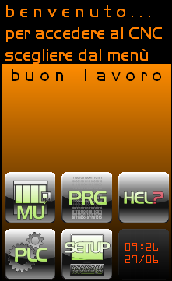

The first menu that appears when the machine is turned on is the illustration that asks you to select one of the “virtual” buttons shown.
It is easy to determine from the icon of each individual button which environment it is referring to:
- MU lets us enter the machine tool environment, the main environment of the CNC in which the work can be started and its development followed graphically in addition to controlling many of the principal functions and displays useful for the processing.
- PLC is the environment that produces, modifies and activates the PLC software and verifies its operation. In addition, it allows some of the most important information of the machine to be displayed and to trace with a “virtual” oscilloscope many of its functions. This environment requires a password for access.
- PRG is the environment in which part-programs are edited and tested and where the copy, cancel, rename operations, etc. are performed.
- SETUP is the environment after MU that has the greatest number of functions because in addition to the various possibilities of configuration there are also various other features that are used to manage the actual CNC such as the management of the origins and the tools and it is possible to see all the system hardware and software information. From this environment, the system can be turned off. Some of the features of this environment require a password for access.
- HELP environment in which it is possible to display the texts of the alarms and other information regarding the use of the CNC.
- CLOCK indicates the current date and time and is used as element of reference for multiple pressing of the keys to enter passwords and to activate some ECS features.

Pressing any one of the keys indicated above displays the environment selected with the exception only of the PLC environment that requires the password defined by the manufacturer to be entered.

MU Environment

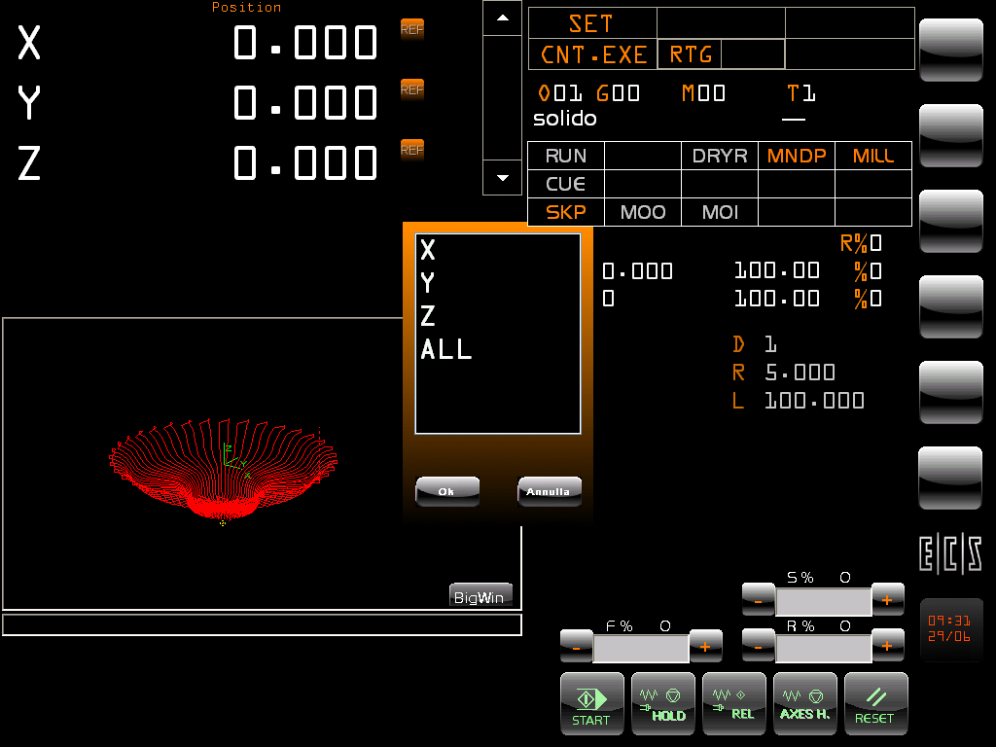

This environment, as can be seen also in the above image, is typical of a CNC in which a lot of information relative to the execution of programs can be seen and from which it is possible to perform all or almost all the machine functions.
Since it is a Touch-Screen, a specific “pen” or simply a fingertip can be used to select, activate, press buttons, etc.
The Touch-Screen allows us to limit the number of external buttons and therefore to make the operator panel simpler besides improving the navigability of the interface.

Visualization of the quotas

In the upper right part of the screen, the first three configured axes can be seen indicating the actual quota.
Scrolling the arrows to the right, one can browse all the configured axes.

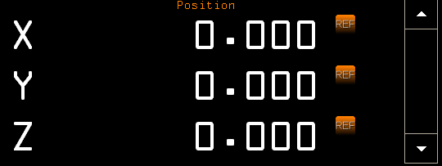

The configured axes can be displayed or not displayed at the option of the PLC or the actual operator who by double clicking on the right side of the display, in the middle of the two scrolling keys, opens a small vertical window, see the illustration below, which allows us to display or hide all or even just some of the configured axes and to display them in the order in which the user/manufacturer considers most suitable for the machine.

On the left, the name of the axes to which the right-hand quota refers is displayed and to the right of the quota there is a series of 6 small icons, arranged in two rows, which represent the status of the axes at that moment.

Clicking on the name activates through the PLC the selection of that axis for those modes, like the JOG, which require that information. When the axis is selected, a coloured bar appears under the name and the quota to indicate in fact that status.

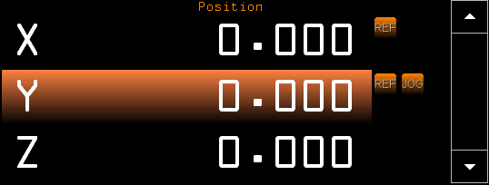

To the right there is a scrolling bar with two arrows that act as scrolling buttons that allow the hidden axes, which due to space are not always visible, to be displayed.
On this same bar, as described above and explained in greater detail later in this chapter, when double clicking a selection mode of the axes to be displayed is activated.

All the values displayed are expressed in mm or in inches depending on the method selected.
If it is displayed in inches, the decimal point will be shifted one place to the left.

Selection window axes to be displayed

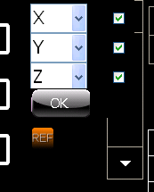

The check mark located to the right of the list indicates whether that axis should be displayed or not while the button that displays the list next to the name allows any one of the configured axes to be displayed thereby changing their order of visualization.

The axis selection window that appears as described above will automatically disappear once acceptance of what was defined is given by pressing the key at the bottom with the word “OK”.

Info:
This window can be moved and placed anywhere on the screen by using the external three-key mouse and clicking the centre key.
This window will change appearance turning grey and can be moved anywhere on the screen by clicking the left key of the mouse and with the cursor placed it in any point of the window.
Once positioned, the system will remember where and, when next displayed, will appear in exactly the same point.
It is possible to move the window from the current position to the original one by clicking with the right key of the mouse on the window selected.

Selection of the axes displayed by PLC

The selection of the axes to be displayed can also be done through PLC which “forces” this display.
For this operation, please refer to the application manual.

Display of the quotas in small format

As can be seen in the illustration, two values are displayed for each axis; to the left is shown the display quota relative to the original set, the right-hand quota will assume different meanings as described below. The orange string at the top of the display indicates the meaning of the values below.
If the left-hand quota is clicked at any time, the image returns to the previous display with large characters.
With a simple click on the right-hand quota, a new display will be activated which in fact includes the current quota and other information concerning the axis.

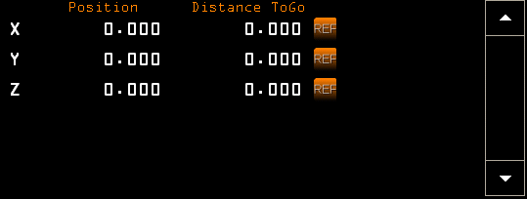

This mode allows us to view in order:
- Distance To Go
- Error value
- Actual quota
- SA counts
- Axis status
- Run Stop

Display of the “Distance To Go”

The “DistanceTo Go” is the distance between the current position of the axis and the end position at the quota programmed. This information is different from zero only when a movement on that axis is programmed and the axis has not yet reached the final quota.

Display of the “Error” value

This value represents the difference between the quota at which the axis is located and the one which should have been reached at that instant. This information is active when the axis is in motion.

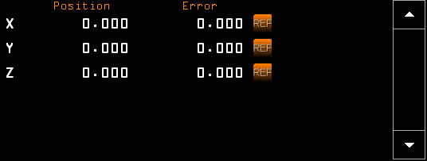

Display of the “Actual” quota

This quota represents the Actual quota of the axis read directly by the transducer and not referred to the active origin.

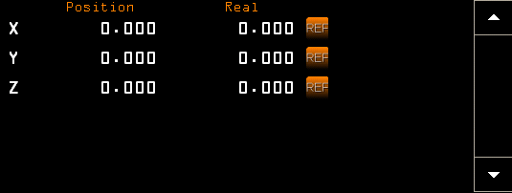

Display of the “SA Counts”

This value indicates the number of counts of the transducer of the axis.

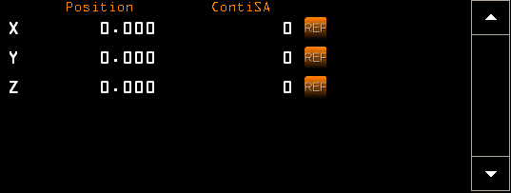.

Display of the “Axis Status” information

This display shows the status, the alarms and the warnings of each individual axis, including the code of the active alarm. The values in grey are not active.

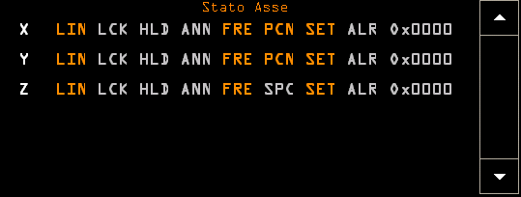.

Display of the “Run Stop” information

If they have been entered in the configuration of this machine, this display shows the values axis by axis of the hardware and software run stops.
The “dashes” indicate that the run stop values have not been entered.

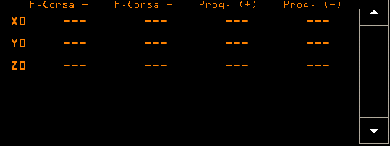

Display of the status icons of the individual axes

Next to the quotas there is a series of icons each of which represents the status or the statuses of the corresponding axis. The meanings of the icons are the following:

 Axis Icon with Negative Active Compensation in Length
 Axis Icon with Positive Active Compensation in Length
 Icon Axis with Active Matrix Dynamic
 Icon Axis with Active RTCP
 Icon Axis with Entered Mirroring
 Icon Axis FRE
 Icon Axis FRV
 Icon Axis Spindle
 Icon Axis PLC
 Icon Axis Selected DRF with Inserted Handwheel
 Icon Axis Selected in JOG
 Icon Axis Selected in JOG with Inserted Handwheel
 Icon Axis Set To Do
 Icon Axis in JOG with Handwheel

Graphic display of the processing in real time (RTG)
The real time graphics of the movements of the machine allow the routes of the tools to be displayed and to show the progress of the processing.

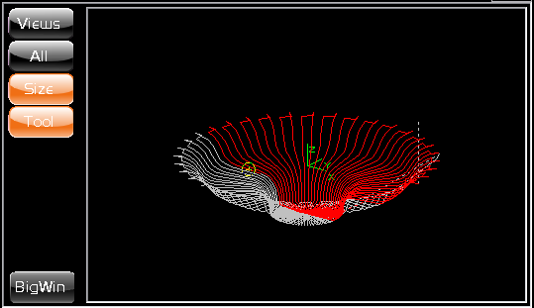

This display is composed of two elements, the graphic and the virtual buttons menu.

Buttons Menu

The menu that normally appears is the basic one and has 5 visible keys and 4 invisible ones.

The visible keys are:
- Views: opens another menu to select the view
- All: displays the whole drawing
- Size: activates/deactivates the limits set by part-program and in general defines the “rough” part to be processed.
- Tool: displays/hides the small circle on the scale drawing with the radius of the tool used.
- BigWin: displays the same window but with larger dimensions while occupying almost the whole screen but maintaining however the same zoom ratio and the same visualization.



The invisible keys are located in the empty space between Tool and BigWin and are only visible when the CNC is in search mode:
- Avanz.: Is used to perform and advanced search within repetitive cycles
- TextPP: Displays in the graphic 3 lines of part-program that allow the position at which the part-program stopped to be identified.
- Prev.: Is used to scroll within the performed processing in order to select the restart point of the part-program
- Next.: Is used to scroll within the performed processing in order to select the restart point of the part-program

“Views” Button
This button activates the submenu of the displays which allows us to display the tools paths in the most appropriate way.

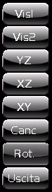

This menu includes the following keys:
- Vis1: 3D display
- Vis2: 3D display with 180° rotation around Z-axis
- YZ: 2D display along X-axis
- XZ: 2D display along Y-axis
- XY: 2D display along Z-axis
- Canc: Cancel the displayed graphic
- Rot.: Rotate the entire drawing relative to an axis
- Exit: To return to the previous menu

“All” Button

This button performs only a zoom in order to make the whole drawing constructed up to that moment visible.
If the limits were activated with the “Size” button, the space which contains the “rough” piece in processing will be displayed. The limits must be programmed in the part-program using the “SIZ: …” command.
In the 3D display, the drawing does not use the entire space but it can be zoomed further with the methods which we will describe later in this manual.

“Size” Button

This button activates/deactivates the use of the limits indicated in the part-program thus forcing the “All” zoom to keep account of it and therefore to obtain a display that integrates these limits.

“Tool” Button

With this button, the display of the tool, which in certain cases may be useful for identifying the exact point in the drawing corresponding to the actual point of the axis on the machine, is activated/deactivated.

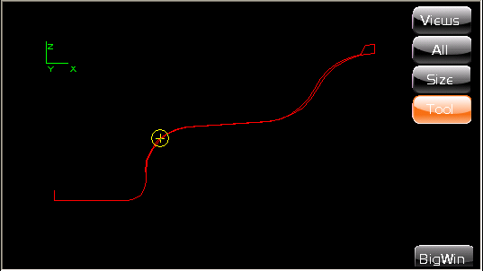

“BigWin” Button

This button allows us to make the display of the graphics larger and therefore more legible especially in cases such as cutting where graphics are used a lot.

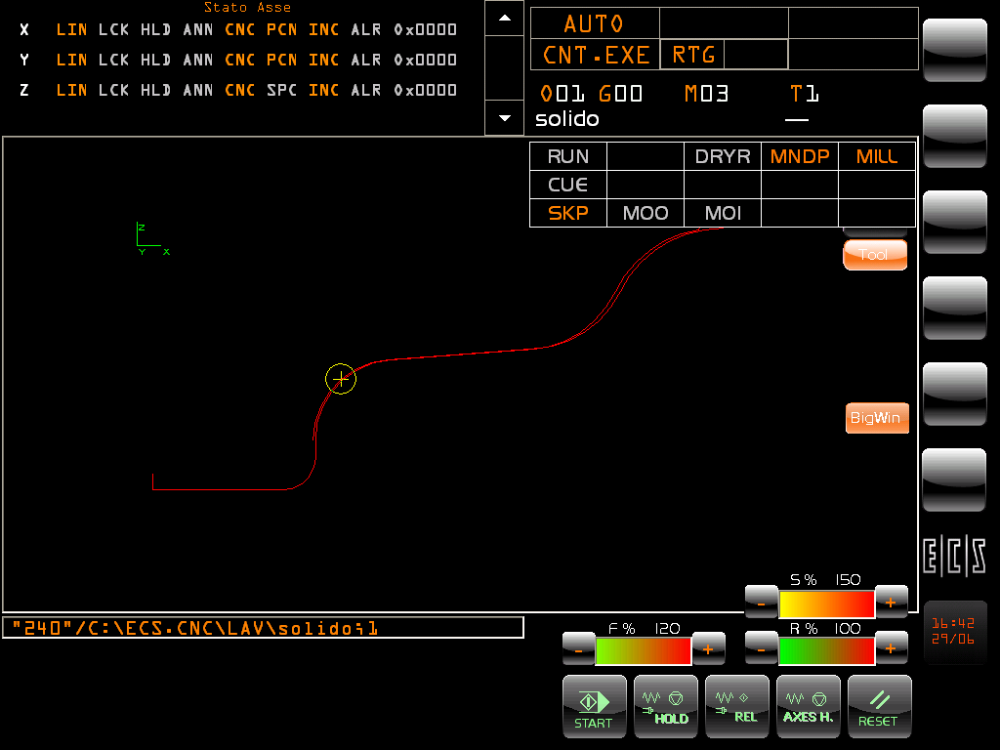

Command String

The command string line, which is located under the RTG graphics, is always visible and is used in “MDI” to indicate which command is being performed and also in other modes such as for example in “Search” for repositioning to indicate the program line to be searched.

Area for inserting Manual Commands (MDI)

This window only appears by selecting the manual mode (MDI) and allows the operator to insert commands manually. With this feature, all the CNC commands can be run.
This window is a true editor which also allows parts of the text or entire lines to be copied, pasted or cancelled. Each time a character is entered it is memorized in a file and the text inserted will reappear even after the CNC has been shut down.

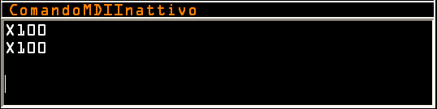

The editing commands that are possible are:

Modify command | Default combination of keys
Backspace | Backspace
Delete | Delete
DeleteNextWord | Ctrl+Delete
DeletePreviousWord | Ctrl+Backspace
EnterLineBreak | Shift+Enter
EnterParagraphBreak | Enter
MoveDownByLine | Down
MoveDownByPage | PageDown
MoveDownByParagraph | Ctrl+Down
MoveLeftByCharacter | Left
MoveLeftByWord | Ctrl+Left
MoveRightByCharacter | Right
MoveRightByWord | Ctrl+Right
MoveToDocumentEnd | Ctrl+End
MoveToDocumentStart | Ctrl+Home
MoveToLineEnd | End
MoveToLineStart | Home
MoveUpByLine | Up
MoveUpByPage | PageUp
MoveUpByParagraph | Ctrl+Up
SelectDownByLine | Shift+Down
SelectDownByPage | Shift+PageDown
SelectDownByParagraph | Ctrl+Shift+Down
SelectLeftByCharacter | Shift+Left
SelectLeftByWord | Ctrl+Shift+Left
SelectRightByCharacter | Shift+Right
SelectRightByWord | Ctrl+Shift+Right
SelectToDocumentEnd | Ctrl+Shift+End
SelectToDocumentStart | Ctrl+Shift+Home
SelectToLineEnd | Shift+End
SelectToLineStart | Shift+Home
SelectUpByLine | Shift+Up
SelectUpByPage | Shift+PageUp
SelectUpByParagraph | Ctrl+Shift+Up
TabBackward | Shift+Tab
TabForward | Tab
ToggleInsert | Insert

Selection axes to be reset (SetAxes)

This dialogue box appears when the machine is started and displays the list of the axes of the machine that must run the set procedure in order to acquire the correct position.

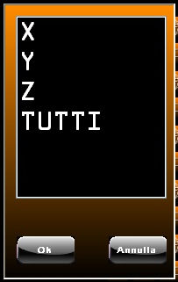

If the operator is temporarily not interested in running the set axes he can hide the box by pressing the “Cancel” key.
The window will reappear when the Reset key of the CNC is pressed or by pressing the Set key again.

In addition to the axes to be set, the wording “ALL” also appears which allows the set axes to be run automatically and in the order set by the manufacturer of the machine.

Once an axis is selected by pressing the “OK” button, the set request is sent to the CNC and the command ready to be run can be seen in the box of the line of the manual commands.

At this point, by pressing the “Start” key of the CNC the set procedure is started.

Display Active CNC Mode

In this display, the active CNC modes can be viewed.

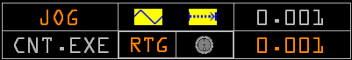

As can be seen in the illustration, the display is divided into rectangles and each one of them represents a type of mode and information.
The writing in grey indicates their inactivity.
The first rectangle in the top left displays the “Active CNC Mode” and can contain the following wording:

- JOG allows each individual axis to be moved manually
- MDI allows commands to be entered manually in the specific window and to run them by pressing the START
- SET allows the set axes to be run for the preparation of the machine
- AUTO allows the work programmes to be run automatically
- SEARCH allows a specific line of part program to be searched or to select graphically on the RTG graphics the point of resumption of the process
- REP allows the processing procedure to resume with the repositioning of the axes and the other scheduled functions. In order to reposition the axes, a list of axes to be repositioned and other functions which were active in the point of resumption of the process will appear.

CNC Mode Selection

The selection of the CNC mode is done by clicking the aforementioned rectangle which makes a box open with the selection buttons of the mode.

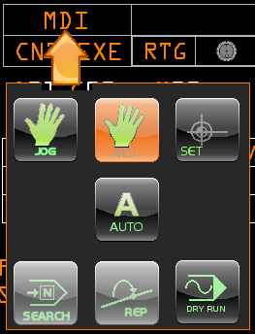

The box in the figure which allows us to select the CNC mode was generated with the “Resource Builder” tool for the customization of the interface which will be described in a later chapter.

CNC Submode Selection

The box with the buttons shown in the figure allows the CNC mode to be selected in addition to the possibility of activating the DRYRUN which enables a run mode at Fast speed.

The first rectangle in the bottom left displays the “Active CNC Submode” and can contain the following wording:

- CNT.EXE Indicates that the CNC is in continuous run
- SNG.EXE Indicates that the CNC is in single run
- CNT.TST Indicates that the CNC is in continuous test
- SNG.TST Indicates that the CNC is in single test

The selection of the CNC submode is done by clicking the aforementioned rectangle which makes a box open with the selection buttons of the mode.

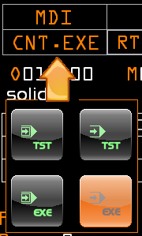

The box in the figure which allows us to select the CNC submode was generated with the “Resource Builder” tool for the customization of the interface which will be described in a later chapter.

JOG Submodes Selection

The rectangle in the top centre displays two icons that represent the operating modes of the JOG and are valid and visible only in this mode:

The first on the left indicates whether it has been selected:

- JOG in Fast speed
- JOG in Work speed

The second on the right indicates whether we are in:

- Continuous Jog
- Step Jog

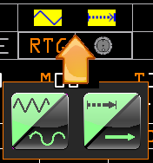

The box in the figure which allows us to select the JOG submode was generated with the “Resource Builder” tool for the customization of the interface which will be described in a later chapter.

Setting the step value of the JOG

When Step JOG is selected, the value of the step increment is displayed in the top right rectangle.
By clicking on the step value, a new box opens in which it is possible to select a default value or to enter one at will.

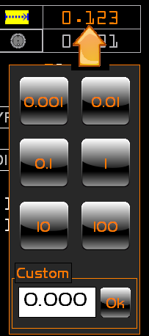

The box displayed which allows us to select the step value for the JOG was generated with the “Resource Builder” tool for the customization of the interface which will be described in a later chapter.

Setting of the JOG with Handwheel

By clicking on the handwheel icon located in middle bottom right of the central rectangle, the operator can select the Jog with or without the handwheel.

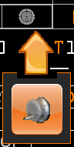

The box displayed, which allows us to select the JOG with handwheel, was generated with the “Resource Builder” tool for the customization of the interface which will be described in a later chapter.

Setting of the Step value for the JOG with Handwheel

When JOG with Handwheel is selected, the value of the step increment is displayed in the bottom right rectangle.
By clicking on the step value, a new box opens in which it is possible to select a default value.
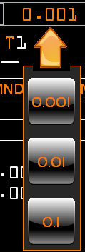

The box displayed, which allows us to select the step value for the JOG with handwheel, was generated with the “Resource Builder” tool for the customization of the interface which will be described in a later chapter.

Selection Real Time Graphics (RTG)

The rectangle in the bottom centre contains the message RTG which allows the real time graphics to be hidden/displayed:

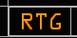

By displaying or hiding the graphics, the quota window is conveniently reduced and in relation to the number of axes configured, which would otherwise be covered by the graphics window.

Processing parameter display

This group represents some of the most important information relative to a working part program.
By clicking on each of them, more detailed information and/or additional features are obtained.
By moving the cursor over each item a text appears which describes the item and the cursor changes into a “hand” indicating that there is in fact a “link” and that therefore it can be clicked.



- Active Origin
- Last Gxx programmed
- Last Mxx programmed
- Tool Code set
- Name of the part program selected
- Indication of the line or the subroutine that is being run at that moment.

Active Origin
This is the origin that is currently active and to which all the processing quotas refer.
By clicking on the “Oxx” string a submenu opens which includes three buttons that permit additional views.


The top button allows the list of the origins to be viewed and is always active.

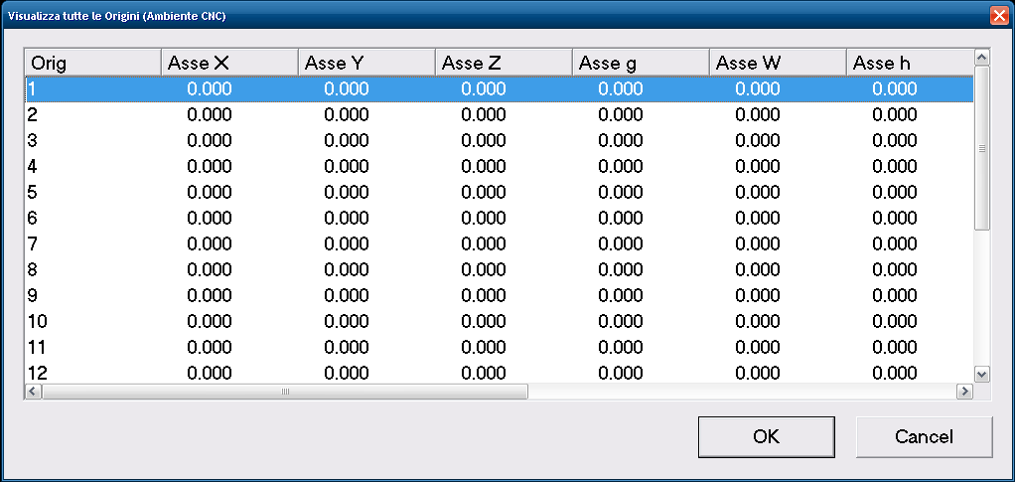

The centre button, active only in manual mode, allows a data entry to be opened in order to change the origin.

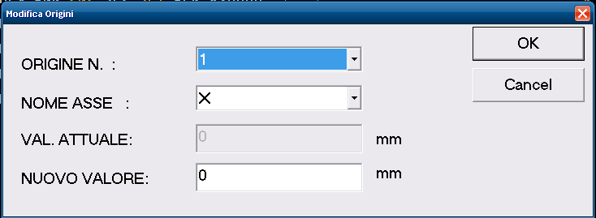

The bottom button, active both in manual and in jog, allows a data entry to be opened to establish the origin by taking the values from the quotas of the axes directly.

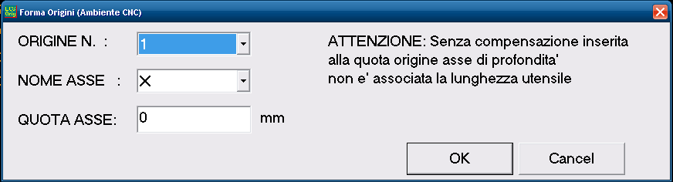

For additional explanations on the management of the origins, please refer to the relative chapter.

Last Gxx function programmed display
This view shows us the last Gxx programmed.
By clicking on the string, the view of all the types of G, being currently active, is displayed.
The new display remains visible until the string of the last G programmed is clicked again.

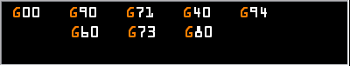

The apparently empty space in this view is actually available for other functions that are not used as often but which are concurrent and therefore need their own space.

Info:
This window can be moved and placed anywhere on the screen by using the external three-key mouse and clicking the centre key.
This window will change appearance turning grey and can be moved anywhere on the screen by clicking the left key of the mouse and placing it with the cursor in any point of the window.
Once positioned, the system will remember where and when next displayed will appear in exactly the same point.
It will be possible at any moment to move window from its current position to the original one by clicking with the right key of the mouse on the window selected.

Last Mxx function programmed display
This view shows us the last Mxx programmed.
By clicking on the string, the view of all the three types of M, being currently active, is displayed.
The new display remains visible until the string of the last M programmed is clicked again.



Info:
This window can be moved and placed anywhere on the screen by using the external three-key mouse and clicking the centre key.
This window will change appearance turning grey and can be moved anywhere on the screen by clicking the left key of the mouse and with the cursor placing it in any point of the window.
Once positioned, the system will remember where and, when next displayed, will appear in exactly the same point.
It will be possible at any moment to move the window from its current position to the original one by clicking with the right key of the mouse on the window selected.

Tool code set display
This display shows us the tool currently set on the spindle.
By clicking on the “Txxx” string a submenu opens which includes five buttons that permit additional views.



Info:
This window can be moved and placed anywhere on the screen by using the external three-key mouse and clicking the centre key.
This window will change appearance turning grey and can be moved anywhere on the screen by clicking the left key of the mouse and with the cursor placing it in any point of the window.
Once positioned, the system will remember where and, when next displayed, will appear in exactly the same point.
It will be possible at any moment to move window from its current position to the original one by clicking with the right key of the mouse on the window selected.

By clicking the first button at the top, the parameters of the tool are displayed:
- D – Adjuster
- R – Tool radius
- L – Tool length

The new display remains visible until the above button is clicked again.

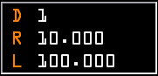

Info:
This window can be moved and placed anywhere on the screen by using the external three-key mouse and clicking the centre key.
This window will change appearance turning grey and can be moved anywhere on the screen by clicking the left key of the mouse and with the cursor placing it in any point of the window.
Once positioned, the system will remember where and, when next displayed, will appear in exactly the same point.
It will be possible at any moment to move window from its current position to the original one by clicking with the right key of the mouse on the window selected.

By clicking the second button from the top, the list of the tools present in the tools table is displayed.
This view allows just the list of tools present in the tools table to be seen.

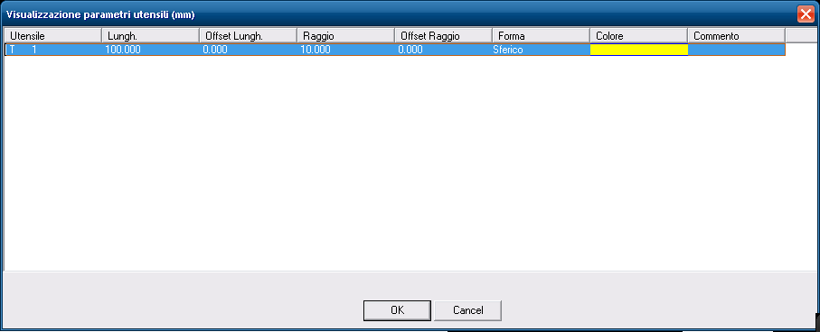

By clicking on the third button from the top, the list of tools present in the tools tables is displayed in order to select the tool to be modified. The confirmation of the selection displays the modification data entry.

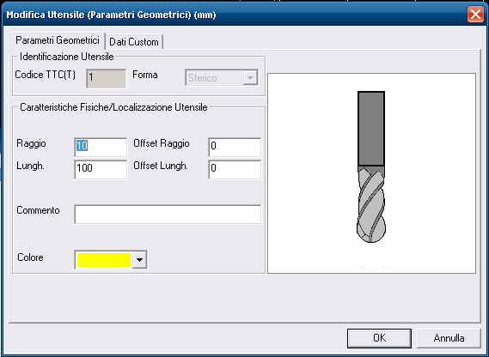

By clicking on the fourth button from the top, the list of tools present in the tools tables is displayed in order to select the tool for which one wants to modify the offsets. The confirmation of the selection displays the modification of the offset.

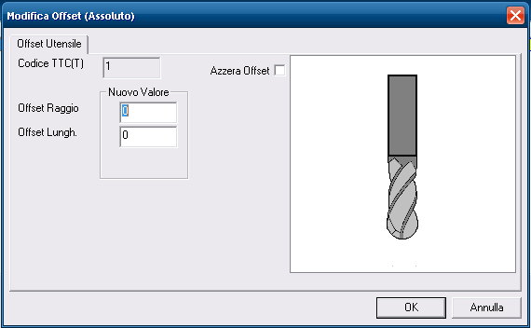

The last button, only active in manual and jog mode and with activated tool compensation, allows the preset to be run through the specific data entry.

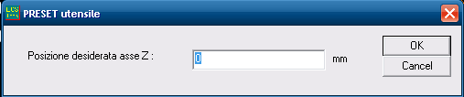

As regards the management of the tools and the tools table, please refer to the relative section.

Name of the selected Part Program display

This display shows us the name of the program being selected for the processing.
By clicking on the display, the program selection window opens.

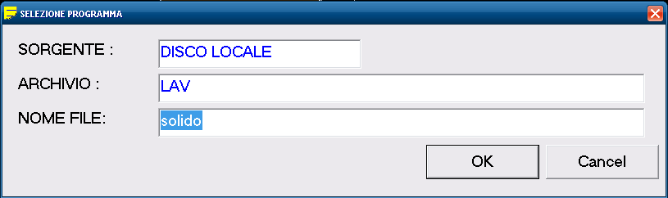

By pressing OK, the selected program will become the work programme.

Display of the line number being executed

This display shows us the line number that the CNC is running.
By clicking the display, a window opens that shows the part program and its progress during the processing.

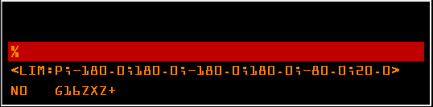

This window, which dynamically shows the lines processed by the CNC, allows one of two different types of view to be selected. The first shows the interpolated lines, that is to say those that are actually being run; the second shows the interpreted lines, which are those that the software is processing to then pass the execution commands to the CNC. This second display generally shows program lines that are considerably ahead of the first display.
To change the display, double-click inside the window. The new display will be recognized besides from the different information also by the light blue colour of the text, which is light orange for the first display.
As regards the display of the sub-programs, they will be displayed in the window but with a superimposed window.

If the user entered the Manufacturer password, two other levels of display will be available. By double clicking on the window, the text will be displayed in light yellow and, just as for the first type of display, the program lines of interpolation will be displayed and not only those of the part program selected but also those of the system sub-programs. By double-clicking again, one enters in the display with the magenta text which allows the interpreted lines to be viewed of the system sub-program as well.

Display of the speed of processing

This group of views shows the processing speed, Feed, Speed and Fast Feed and the relative numerical override values.

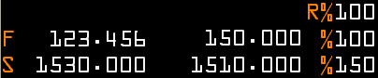

The information shown is:
- Feed or work programmed
- Feed of work
- Spindle Feed programmed
- Spindle Feed
- Fast Feed override value
- Feed override value
- Speed override value

Also in this display, by moving the cursor onto a value the relative unit of measurement is obtained.
The adjustment of the overrides is done through an external command or through the virtual trimmers built with the Resource Builder and managed by the PLC. Features described in the next chapter.

PLC Environment

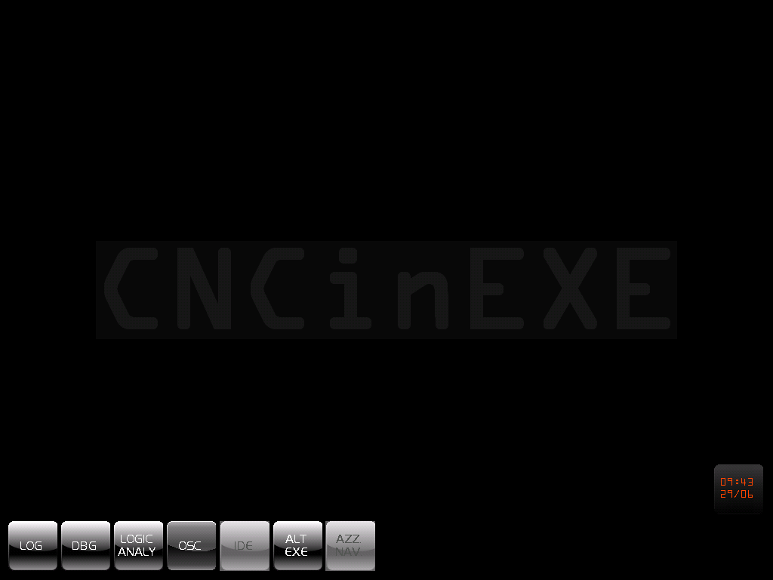

The menu that appears when entering this environment contains the following buttons:



LOG (PLC LOGIC ENVIRONMENT)
The selection “PLC Logic” allows the PLC equations to be displayed showing their current values of the synonyms. From this environment it is also possible to activate directly the Logical Analyser tool.
When selecting, the name of the desired Logic File is requested.
The selection follows the standard rules. In fact, one operates on a Data Entry of the type illustrated in FIG. 7-9 in which with key [↓] it is possible to scroll the list of files that can be selected (those with extension .C contained in the directory C:\ECS.CNC\SWPLC\WRK).
Once the File is selected, the necessary part of the CNC display will be divided into two windows.
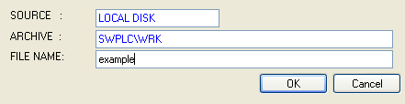
FIG. 7-9 Data Entry “Selezione File di cui si intende visualizzare il valore corrente dei Sinonimi”

As can be seen in FIG. 7-10, the top window is used to display the variables selected, the lower one instead displays the logic file (.C) selected and it can be scrolled through.

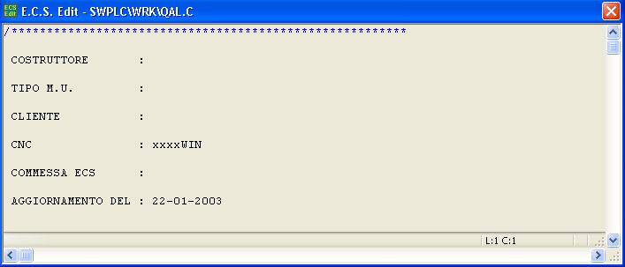
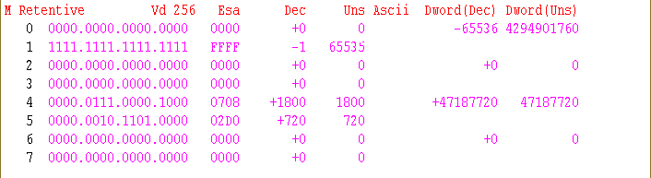
FIG.7-10 Screen associated with the selection “PLC Logic”

In this context, the function keys [F1] – [F10] assume the following appearance:

which we now review in detail:

Selections “Next/Previous Variable Type”
This allows the display window to be switched from the current format to the one associated respectively to the next/previous type of variables (with reference to the list supplied in Select Type of Variables).

Selection “Keys for PLC Window/Keys for Variables Window”
This selection is only active with the top window used to display the variables. In this case, in fact, it is used to switch the “Focus” between the two windows.
That is to say allow the Source or the Variables List file to be scrolled through.

Selection “Edit”


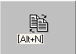It activates the following menu:

The selections available here allow:

Skip to line N.
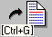
Lets the operator “skip” to the line specified.

String search
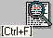
Permits the search, within the file being displayed, of the first recurrence of a string specified by the operator.

Repeat String search

Repeats the search “triggered” with the previous command.

Open second File
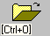
Allows a second File to be displayed. The selection is done with the same methods and help already described for the opening of the first File.

Switch File
It enables the operator to switch the display window between the first file and the second one eventually opened with the previous command.

Close Second File
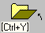
Allows the File currently open to be closed. The command is important only when working with two files open at the same time.

Selection “CNC/PLC Variables”
Allows switching between, in the top window, the PLC Variables and the CNC Variables display.

Selection “Search for Synonyms”
It allows the operator to define, by directly completing a data entry, the synonym for which one wants to know the actual value.

Selection “Display Synonyms Status”
By pressing this key, the top window is reset. The “Focus” is automatically assigned to the window in which the .C file is displayed. When, while scrolling through the source, lines are encountered containing synonyms, their value is given unencoded in the top window. In the source file, the synonyms are instead shown on a light blue background. They are written in black if they have a value of 0 and in yellow if they have a value other than 0.

Selection “Variables List Management”
It permits the display and/or forcing of the status of a set up to 10 Variables freely selected. For details, please refer to Paragraph 7.1.1.6

Selection “Logical Analyser”

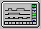
This selection activates the “Logical Analyser” tool described in detail later in this Manual.
The relative data will appear in the top window just as the associated keys F1-F10 will be made available. The tool can thus be set and activated. Both when activating it (with the “Start” key) and deactivating it (with the “Exit” key), the top window and the functions keys will return to assuming the features that they had previously. Once the Logical Analyser is activated, it will continue to work in the background until the event specified as trigger occurs.

Selection “Exit”

Commands the exit from the “Logic PLC” environment and the closing of the relative window.

DBG (DEBUG PLC ENVIRONMENT)
The “Debug PLC” selection allows the “run time” value to be displayed for all the Variables within both the CNC and the PLC. This is done through another menu level with a differentiated appearance depending on whether it is referring to parameters of the CNC or the PLC.

Display of the PLC Variables
This is the configuration that is activated as default.
In this case, the F1-F10 function keys assume the following appearance:
FIG. 7-1 “Debug PLC” menu in case the of PLC variables is required

Let us review in detail the meaning of the various selections that can be implemented:

Selection “CNC/PLC Variables”
It allows the switch to the view of the CNC/PLC Variables.

Selection “Select Type of Variables”
With this key, it is possible to select the type of PLC variable that one wants to monitor. The structure on which one operates is a list. See FIG.7-2. The selection is done by scrolling through a specific list with the keys [↑], [↓], [PGUP], [PGDN], [HOME] or [END]. It is also possible to accelerate the selection by keying in the initial character of the desired selection.
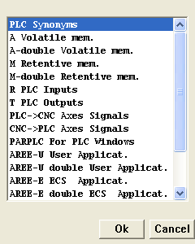
FIG.7-2
List “Selection type of PLC variables”

Brief characteristics of the variables that can be selected:
- PLC Synonyms Provides all the synonyms generated during compilation phase. By operating the selection “Complete Synonyms List” all those defined in the PLC Base ECS (File DF_SYN.INC) + those defined in the logic of the user.
- 512 word A non Retentive
- 128 Double words (Float) A non Retentive
- 256 word M Retentive
- 128 Double words (Float) M Retentive
- Word R that is the local Inputs detected by the SW when the CNC is turned on.
- Word T that is the local Outputs detected by the SW when the CNC is turned on.
- Word Axes Signals interchange PLC → CNC (one word per configured axis).
- Word Axes Signals interchange CNC → PLC (four words per configured axis).
- 25 Word PARPLCxx used in the interchange with the windows generated through Resource Builder (the display is exclusively in float format).
- 512 Word U-Areas used as interchange between PLC and User applications realized in Windows® environment.
- 256 double Word U-Areas used as interchange between PLC and User applications realized in Windows® environment.
- 512 Word E-Areas used as interchange between PLC and ECS applications realized in Windows® environment.
- 256 double Word E-Areas used as interchange between PLC and ECS applications realized in Windows® environment.
- 128 Timers (The display of the content, expressed in seconds, is exclusively in float format).
- 32 PLC sequencers (The display is exclusively in full format).
- CAN BUS Input that is the Inputs (Digital, Analogue and Encoder) eventually configured. The individual Inputs are identified based on the following “syntaxes”: ID: Node Address Input Type Input Value Where: Input type = di (Digital Input) / ai (Analogue Input) / ei (Encoder Input)
- CAN BUS Output that is the Outputs (Digital and Analogue) eventually configured. The individual Outputs are identified based on the following “syntaxes”: ID: Node Address Output Type Output Value Where: Output type = do (Digital Output) / ao (Analogue Output
Note: Where not specified otherwise, the display of the contents of the variables is done at the same time in the formats Binary, Hexadecimal, ASCII and in certain cases Octal.

Selection “Next/Prev. Type of Var.”
This allows the display window to be switched from the current format to the one associated respectively to the next/previous type of variables (with reference to the list offered in Select Type of Variables).

Selection “Next/Previous Variable”
It allows the cursor to be moved, within the current display format, on the next and previous position respectively. In fact it has the same effect as the keys [↑] and [↓].

Selection “Search for Synonym”
It allows the operator to introduce, by directly completing a specific Data Entry (see Fig.7-3), the synonym for which one wants to know the actual value.
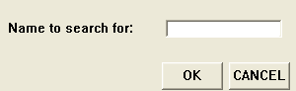
FIG. 7-3 Data Entry ”Search” Synonym

Selection “Variables List Management”
This selection allows groups to be defined up to 10 PLC variables (also belonging to different typologies) for which it will be possible to define or modify “one time” or continuously the value during the execution of the PLC.
In particular, forcing is extremely useful during the debug phase of the PLC, avoiding in many cases having to modify and recompile the PLC. The selection generates the appearance of the window and the associated submenu illustrated in FIG.7-4:

Description of the various features available:

Modify Variables List
Allows changes to be made to the List of Variables currently active (that is the one currently displayed). The modification methods are the same ones used for the creation of a new list (for specific details see Paragraph 7.1.1.6.4)

Save Variables List
Allows the currently active list of variables to be saved in a file (characterized by extension .VAR and content in the directory C:\ECS.CNC\LOGANAL). The definition of the file is guided completely through a specific Data Entry.

Load Variables List
Allows the list of variables currently displayed to be replaced with a list previously saved with the command “Save Variables List”. The selection of the file is guided completely through a specific Data Entry.

New Variables List
Allows defining, through the window illustrated in FIG.7-5, up to 10 different PLC variables which will constitute the new list.

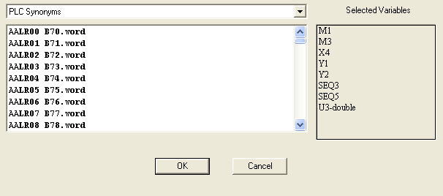
List in which to select the type of Variable PLC
List of the variables already selected
Variables that can be selected within the preselected type
FIG.7-5 Window used for the creation / modification of a List of Variables
If there is no mouse, in the structure of FIG.7-5, one moves between the various fields, following the Windows® rules with the [TAB] key.
In the 2 lists dedicated to the selection of the type of variable and the variable, it is instead possible to move around with the following keys: [↑], [↓], [PgUp], [PgDn], [Home], [End] or the initial character of the desired selection.
The selection / deselection of a variable in the list are done with the key [Space].
Its insertion or its cancellation from the list is instead possible with the [TAB] key.
The [Enter] key closes the selection moving on to requesting where to eventually save the data. With the [ESC] key it is instead possible to abort the operation at any time.

Delete Variables List
It allows a .VAR file to be eliminated from those present in the directory C:\ECS.CNC\LOGANAL. The selection modes of the file are the standard ones. Before physically eliminating the file, additional consent is requested from the operator.

Define Values to be forced
This key must be unblocked in advance by keying in a Password.
By operating on the Variables List currently active, it allows to set how to operate at the level of single variable.
It is in fact possible to define if one wants to simply display the value of the variable (Read Mode) or force its value “one-time” (Write Once Mode) or continuously (Write Continuous Mode). In the last 2 cases it is moreover possible to the value that one intends to force by expressing it in the most suitable format (Binary, Hexadecimal or Decimal).
It is important however to note that with this selection one is limited to exclusively establishing the operating method desired and not to activating it. The structure in which one operates is provided in FIG.7-6. Moving between the various fields is done in the usual way using the keys [TAB] and [SHIFT]+ [TAB]. In particular [TAB] also updates the selection operated.
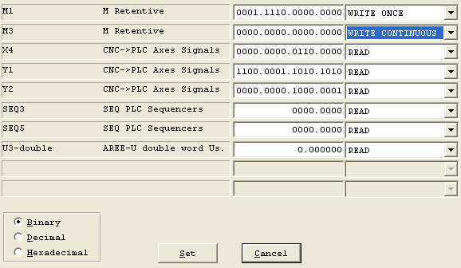
Variables Type of Variables
Value variable Operating Method
Method of Display/Setting the value of the variable when expressed in byte, word and double word.
FIG.7-6 Window for setting the Operating Method and the Forcing Values

Enable Variables “Forcing”
This key must be unblocked in advance by keying in a password. It allows the “forcings” eventually set through the selection described in the previous paragraph to become operative.
It must be pointed out that a variable forced to a default value through the “Write Once” mode will remain such until the PLC itself remodifies the value. If instead the variable is “forced” with the “Write Continuous” mode, it will keep the value set for the entire time the PLC is in operation (overwriting continuously the value eventually initialized by it) until the CNC is placed in ALT (and consequently the PLC stopped) or the “forcing” mode is removed through the specific selection.
However, please remember that, if the variables on which one is operating with “Forcing” are the retentive type and are not reinitialized by the PLC, the effects of the operation will extend also to subsequent restarts of the CNC.

Disable Variables “Forcing”
This key must be unblocked in advance by keying in a password. It allows the “forcing” mode of the variables set as described in Paragraph 7.1.1.6.6 and enabled as explained in Paragraph 7.1.1.6.7 to be deactivated.

Selection “Exit”
Commands the exit from the “Debug PLC” environment and the closing of the relative window.

Display of the CNC Variables
As already stated, this menu is accessed through the key “CNC/PLC Variables”. In this case, the function keys F1-F10 assume the following appearance:
Let us review in detail the meaning of the various selections that can be implemented:
FIG. 7-7 “Debug PLC” menu in case the display of the CNC variables is requested

Selection “Select Type of Variables”
With this key, it is possible to select the type of variables that one wants to monitor. The structure on which one operates is a list, see FIG.7-8. The selection will be done by scrolling with the keys [↑], [↓], [PGUP], [PGDN], [HOME] or [END] in a specific list. It is also possible to speed up the selection by keying in the initial character of the desired selection.
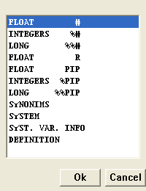
FIG.7-8
List “Selection type of CNC Variables”

Brief characteristics of the variables that can be selected:
- 1000 variables R real type (Float 64 bit)). From R0 to R999 retentive available to the user. 1000 variables R real type (Float 64 bit). From R1050 to R2049 non retentive available to the user. 50 variables R real type (Float 64 bit) from R1000 to R1049 for the exclusive use of ECS.
- 700 variables # with real type direct access (Float). Of which 200, from #300 to #499, available to the Manufacturer, the others for the exclusive use of ECS.
- 250 variables %# integer type direct access. Of which 100 ,from %#50 to %#99 and from %#200 to %#249, available to the Manufacturer , the other for the exclusive use of ECS.
- 250 variables %%# double integer type direct access. Of which 150, from %%#50 to %%#199, available to the Manufacturer, the others for the exclusive use of ECS.
- 50 triletteral variables PIP real type (which can be defined through the LIP instruction <SYS:xxx=#...>).
- 10 triletteral variables %PIP integer type (which can be defined through the LIP instruction <SYS:xxx=#...>).
- 10 triletteral variables %%PIP double integer type.
- 300 Synonyms (Used in the parametric programming of the Macros).
- Variables System V (Float, integer and double integer variables) previously selected through the selection “Definition” (for details see Note below).

Notes:
The selection “Definition” does not indicate a specific type of variables but allows which V type System Variables one intends to monitor with the homonymous selection.
The selection is done by scrolling down a list containing all the V Variables defined in the CNC. The structure can be scrolled with the keys [↑], [↓], [PGUP], [PGDN], [HOME] and [END].
The variable is selected with the character [SPACE].
The operation is closed with the key [ENTER].
In this context the following keys are also enabled:
[F4] or [ESC] → Exit.
[F6] → More information on the variable currently “pointed on”.
[F7] → Search for a string.
[F8] → Repeat the search for the string defined with [F7].

Selections “Next/Previous Variable Type”
For details see Paragraph 7.1.1.3

Selections “Next/Previous Variable”
For details see Paragraph 7.1.1.4

Selection “CNC/PLC Variables”
Allows switching to the display of PLC Variables already described in Paragraph 7.1.1.1.

Selection “Details”
Exclusively enabled with the display format of the System Variables active, gives greater information on the variable currently selected.

Selection “V Variables Mngt”
Enabled exclusively with display format of the System Variables, activates the following list, within which with [↓], [↑], and [ENTER], it is possible to select:

Change Output Format
Save Variables
Restore Variables
Where:
“Change Format” allows the display format of the V Variable to be modified when selected (for example from Integer to Binary).

“Save Variables” allows to be saved in a file (which will have the extension .VAR and which will allocated to the directory C:\CNC.ECS\LAV\WORK) the configured set of V variables (also the display formats eventually defined are also saved). The selection modes of the File are the standard ones.
“Restore Variables” allows a set of V Variables previously saved with the “Save Variables” selection to be reactivated. The selection is guided among the *.VAR files located in C:\ECS.CNC\LAV\WORK.

Selection “Exit”
Commands to exit from the “Debug PLC” environment and the closing of the relative window displaying Variables.

OSC (Oscilloscope)
See specific documentation.

IDE
The tool activated with this selection allows the development (Editing and Compilation) of the Source File(s) of the logic of the Tool Machine; activation is possible exclusively in ALT status (Logic not in operation).
At this point a video screen will appear which will show, in the top left the current configuration of compilation (the type of synonyms list which one wants to generate); the function keys [F1] – [F10] will moreover assume the following appearance:

Now let us analyse the meaning of the various keys.

Selection “Modify/Create PLC Files”
By operating this selection, the user will at first be asked for the name of the file that he intends to create or modify. The selection approach is the standard one and is based on the window shown in FIG. 6-2.
Within this window, it is possible:
- To write directly the name of the File and then to open it or create it with [ENTER].
- Choose the file among those already existing in the directory C:\ECS.CNC\SWPLC\WRK (specifically dedicated for the PLC files). For this purpose, press the [↓] key, then scroll down the list with the keys: [↑] , [↓], [PgDn], [PGUp] , [Home] and [End] and select the file with [ENTER].
- Potentially abort the operation by pressing [ESC].

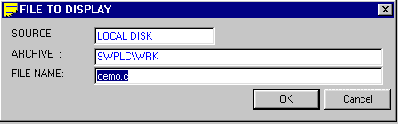
FIG. 6 - 2 Window
“Modify/Create PLC File”

As default, the selection is set to work on files with the extension .C (Source Files). Should one want to display/modify also other files, which must however be located in the directory C:\ECS.CNC\SWPLC\WRK, it is enough to specify, using the Jolly character [*], the file group to which one intends to refer. The rules to be used are those, now universally known, of the DOS®.

For example, if one wants to carry out the selection from among all the files located in the directory \WRK is will be sufficient to key in, next to the field “NAME FILE”, the string “*.*” and then press [↓].
Having done this, the file selected will open in editing. This operation will be carried out by using a special version of the ECS standard editor specifically developed to provide all the necessary help in the construction of a Logic file.

The Editing Window
Once the file is entered (or selected), it will be opened in Editing starting from its beginning. The Editing window occupies the whole screen with the exclusion of the 2 areas dedicated to the management of the function keys F1-F10 and P1-P8 (in the version installed on PC the area on the CNC for the keys P1 – P8 is also available).
In the window, in addition to the name of the file (Complete path) are indicated the line and the column of the current position of the cursor. In this phase, the active keys are:

← | Controls the movement of the cursor by one character to the left, on the current line. Having reached the beginning of the current line it moves the cursor to the last character of the previous line
→ | Controls the movement of the cursor by one character to the right, on the current line. Having reached the end of the current line it moves the cursor to the first character of the next line.
BACKSPACE | Deletes the character to the left of the cursor on the current line. Having deleted the first character of the current line, it moves on to cancel the last character of the preceding line.
HOME | Pressed once it takes the cursor to the first character of the current line.  Pressed a second time, it takes the cursor to the first character.
END | Pressed once it takes the cursor to the last character of the current line. Pressed a second time, it takes the cursor to the last character of the text.
TAB | Inserts in the text a TAB tabulation jump. The current position will therefore move to the first valid tabulation (the tabulations are set every 8 characters).
↑ | Moves the cursor to the previous line. The column remains the same or becomes the last position if the previous line is shorter than the current one.
↓ | Moves the cursor to the next line. The column remains the same or becomes the last position if the next line is shorter than the current one.
PGUP | Takes the cursor to the first character of the previous page.
PGDN | Takes the cursor to the first character of the next page.
DEL | Deletes the character on which the cursor is pointed and moves the cursor one place to the left. If it is on the first character of the current line. Once this character is deleted it will move the cursor to the last character of the previous line.
INS | If enabled, it enters the character keyed in where the cursor is currently located. The pre-existing text is shifted to the right.  If disabled, it replaces the character on which the cursor is point with the character keyed in. The cursor moves one position to the right.  When Editor is activated, the default is “insert enabled”.
SHIFT ↓ | With the cursor position at the start of the line, it allows the current line to be selected shifting the cursor to the next line. The line selected is highlighted in blue. By keeping the two keys pressed down it is possible to select several lines.
SHIFT ↑ | With the cursor position at the start of the line, it allows the current line to be selected shifting the cursor to the previous line. The line selected is highlighted in blue. By keeping the two keys pressed down it is possible to select several lines.
The ten Function keys instead assume the following significance:

Selection “Synonyms Text in Italian/English”
This selection allows, regardless of the languages configured in the CNC, the activation of the Synonyms search and the relative Help, in Italian or in English.

Selection “Synonyms into the Line”
This selection gives the summary meaning of a synonym previously selected in the Source File that is being edited.

Selection “List All Synonyms”
This selection allows the list to be viewed, in alphabetical order, containing a summary description of all the synonyms defined in the PLC.

Selection “Synonyms by Argument”
This selection allows the list to be viewed that contains a summary description of all the synonyms pertaining to a certain subject.
The operator, in this case, before being able to scroll through the list, is asked to selected the argument with the keys [↑], [↓] and [Space] (see FIG. 6-3).
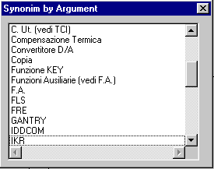
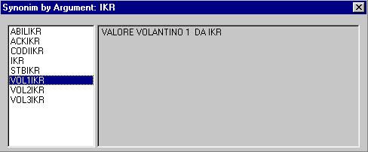
FIG. 6-3
List selection Subject and list description associated Synonyms associati.

Selection “Edit”
By pressing the key, the submenu is activated:
Where the function keys assume the following meaning:

Skip to line N.
Permits the “skip” to the line specified by the operator.

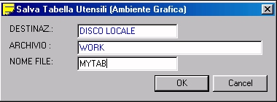
String Search
FIG. 5-22 Data Entry: “Salva File Utensili”
Permits the search, within the file being edited, of the first recurrence of a string specified by the operator.

Repeat String Search
Repeats the search “triggered” with the previous command.

Replace String
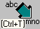
Allows searching, within the file being edited, a string replacing it with another one. Obviously both the text searched and the one replaced are defined, through specific Data Entry, by the operator.

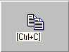

Copy
Allows to copy in the transit buffer of the Editor the text selected with the combination of keys [Shift] [↑] and [Shift] [↓].

Cut
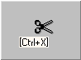Eliminates the text selected through the combinations of keys [Shift] [↑] and [Shift] [↓]. At the same time, the text is saved in the transit buffer of the Editor.

Paste
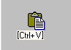Allows to copy, immediately after the line that is currently active, the content of the transit buffer of the Editor.

Open second File
Allows a second File to be opened in Editing. The selection is done with the same methods and help already described for the opening of the first File.

Switch File
Allows the Editing window to switch between the first file and the second one eventually opened with the previous command.

Close Second File
Allows the File currently open to be closed. The command is important only when working with two files open at the same time.

Selection “Operations on File”

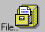
By pressing the key, the following submenu is activated:

As can be seen, the keys from [F4] to [F10] assume the same meaning already described in the preceding paragraph; let us instead analyse the functions associated with the keys [F1] – [F3].

Save Changes Made
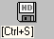
Allows the current content of the File in Editing to be saved in the directory C:\ECS.CNC\SWPLC\WRK.

Save Buffer on File
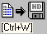
Allows to save on a File, defined by the operator in the directory C:\ECS.CNC\SWPLC\WRK, the content of the transit buffer of the Editor.

Insert Content of a File
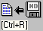
Allows the content of a specified file to be entered immediately after the active line. The selection of the file to be entered will be done according to the methods of “File Selection” already described.


Selection “Help”
Pressing the key makes the Help window appear shown in FIG. 6-4 . Window which will disappear by pressing [ESC] or [ENTER].

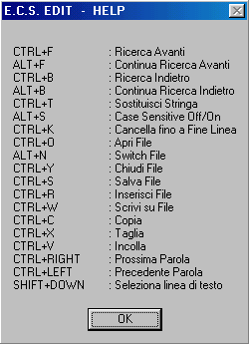
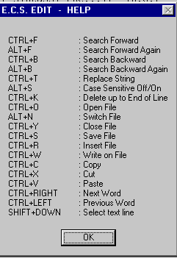
FIG. 6.4 Editor Help window

Selection “Exit”
By pressing this key one leaves the “Modify/Create PLC File” environment. The operator will be asked if he wants to save or not the changes possibly made to the File in Editing.

The selection “Construct PLC”
Starts the compilation or verification of the .C modules included in the design.
The type of operation activated will be the one previously arranged with the key “Options” (see Paragraph 6.5). The operation, to be performed, requires the prior installation of the Compiler. We remind you that this tool, subject to a specific User Licence, is not supplied with the CNC but must be ordered separately.
If a single licence was purchased for several CNC it is necessary, at the end of the fine tuning of the PLC, to take care of uninstalling the SW using the specific key.

Selection “Cross Reference”
This selection generates the activation of the following submenu:

Where:
Create Cross Reference → Allows a table to be generated that combines with each Synonym the File and in it the Line where it is used. In particular, it is pointed out where the Synonym is initialized through allocation (Synonym = Value;). The table keeps tracks of the Type of Synonym List selected (Complete or Reduced). To be able to be created it obviously requires that the PLC have been compiled in advance. If this has not yet been done or if, following the last compilation, the type of Synonym List was modified, the key is automatically disabled.
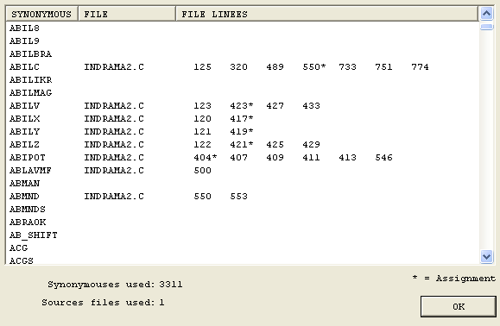
FIG. 6-5 Cross Reference Tables created with Synonym List complete
Like synonums, also listed, in addition to those defined by the user, are the ECS ones contained in the file DF_SYN.INC
Linesin which the synonym is used. The character “*” indicates where it is also inizialized

Note:
Once the table is constructed, to save it temporarily (until exiting the PLC Development environment or recompiling) it is necessary, in the structure of FIG.6-5, to press the key OK.
Display Cross Reference → Allows the structure generated with the selection “Create Cross Reference” to be displayed later.
Save Cross Reference → Allows the table generated with the selection “Create Cross Reference” to be saved permanently. At first, saving is suggested in guided mode on the removable unit connected to PC (typically the Floppy Disk drive). Secondly, it is instead possible to select, with the normal rules of Windows ® “navigation”, as destination any one of the accessible Logic Units and, within these, an existing Directory or one created for the purpose.
The saved file, characterized by extension “.PLC” can later be displayed through a normal editor (for example NOTEPAD®)
Print Cross Reference → Allows the table previously created with the selection “Create Cross Reference” to be printed. The command obviously requires that a printer be configured previously.

Selection “List PLC Files”
The development system allows a single project to be managed at a time.
By “List PLC File” we mean the list of source files (.C) constituting the project.
This selection allows the list of files that constitute the project to be defined and/or modified.
In addition to the source files, the ALLAR*.MU (alarm and warning messages in various languages) files, the PLC_SYN.INC (file includes synonyms defined in the Logic) file and the QAL.MAK file, which contains all the directives for the compilation of the project, are associated with a project.
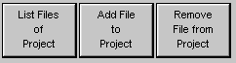
The “List PLC Files” selection activates the following submenu:

Where:
List Files of Project → Allows the files (.C) constituting the project to be listed.
Add File to Project → Allows a file (.C) to be added to the project by selecting it from those included in the directory C:\ECS.CNC\SWPLC\WRK.
Remove File from Project → Allows a file (.C) to be eliminated from the list of files associated with the project.
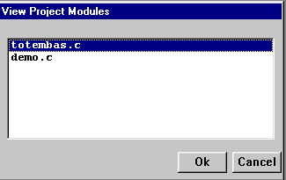
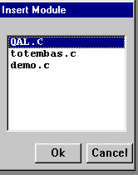
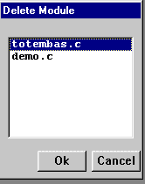
FIG.6-6 Structures for the Display, the Insertion and the Cancellation of the Files constituting the PLC project

Selection “Options”
This selection allows one to set whether during the compilation one wants to create a list that includes exclusively the synonyms that were defined by the user (Reduced Synonym List
We remind you that the Synonym List generated in this way will be used by the CNC during the Debug phase of the Logic
In addition it permits the installation of the Compiler necessary to create the executable PLC (Load Compilers key) and then, once the job is completed, to uninstall it (Unload Compilers key). The above operations will be made possible with the following Function Keys:

Warning!!
The compiler is conditioned by the Operating System installed on the CNC. As a result, before “Download” it is necessary to check its version and its compatibility with the S.O. in use (Windows 98SE or Windows XP Embedded)

Selection “Services”
This selection activates the following Function Keys:

The selection “Copy File” allows any type of file to be transferred by selecting source and destination from among all the defined Logic Units and Directories. The operations of selection of the path “Source” and “Destination” will take place in compliance with the standard Windows ® rules.
The selection “Delete File” allows any file located in the work directory C:\ECS.CNC\SWPLC\WRK to be cancelled.
The selection “Save Project” allows the files associated with the PLC project being developed to be saved (ALLAR*.MU, PLC_SYN.INC, *.C and QAL.MAK) in the removable storage device connected to the CNC (1,44MB disk or I/Omega Zip) or, if these are not available, in any accessible Logic Unit and Directory.
The selection “Load Project” allows the loading of the files associated with a project which had been previously saved on a 1.44MB disk or a 100MB I/Omega Zip or, if these are not available, in any accessible Logic Unit and Directory into the directory C:\ECS.CNC\SWPLC\WRK of the CNC.

Selection “PLC Menu”
This selection allows an SW tool that ECS has finetuned to permit the complete characterization and logic interconnection of the keys P1-P8 used by the PLC to be activated. For a detailed description of this environment please refer to Chapter 5 of this manual.

Selection “Create Ethercat headings”
Automatic creation of the headings file relative to the EtherCAT configuration necessary for the compilation.
This file must be regenerated every time the hardware configuration relative to I/O and EtherCAT Modules is modified.

Selection “Exit”
This selection allows one to exit the Creation/Modification of the PLC environment.

ALT EXE
Allows the switching of the PLC and the CNC from the ALT to the execution (EXE) status and
vice versa.
The ALT condition deactivates all the outputs of the PLC and makes it so that the axes are no longer
controlled in position. The outputs of the D/A converters, used for the reference of speed
To the drives, are automatically set at 0. In case of Drive digitally interfaces the command
Speed null is sent.
This operation requires however, for it to take effect, a few msec.
As a result, to avoid unwanted movements of the axes when turning on the CNC in
ALT, it is necessary that the power and the enabling of the drives of the motors be appropriately
conditioned via HW.
By switching the CNC from ALT to EXE, it is initialized based on the contents of the calibration files (For details see “Calibration Manual” Code 720P385) and the axes are “hooked” in the position in which they find themselves placing the reference of speed at 0. At the same time, the PLC is also setinto operation.

AZZ NAV
This function resets the data contained in the RAM of the CNC (Navetta), causing the loss of the non volatile data contained therein.
It must be used directly by the ECS Helpline or in any case under its supervision.
The selection, in order to be activated, requires the CNC be in ALT.

PRG Environment
This is the programming environment where the part programs can be edited, verified and run.

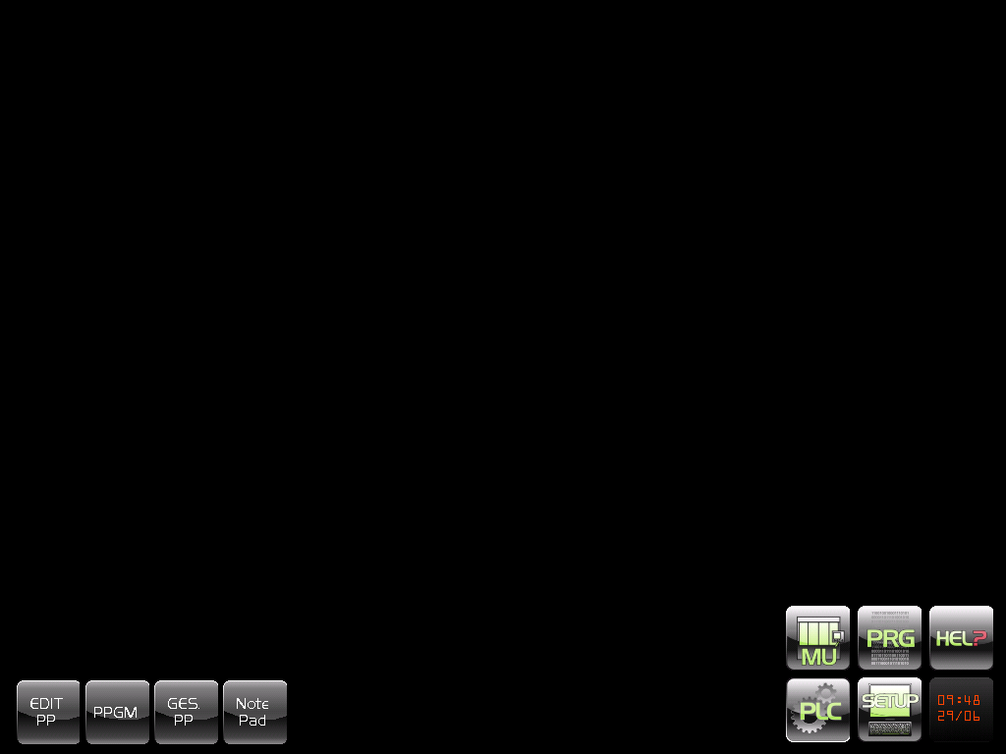

EDIT PP
The first button on the left opens the actual editing environment of the part programs.

Selection of the File to be edited

After pressing the key on the screen, the Data Entry shown in FIG. 5-1 used to identify the File one wants to open will appear:
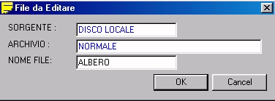
FIG. 5-1 Data Entry: “Selection File in Editing”

Positioned on the field “NAME FILE”, it will be possible to key in the name of the File to be edited. If the file already exists, it is possible to opt for a Selection Wizard. With the [↓] key, a list will in fact open containing all the Part Programs available in the Archive selected (typically C:\ECS.CNC\LAV).
This structure, which holds the memory still as a whole available in the archive as well as, for each file, the current size and the date and time of creation or last modification, can be scrolled at will using the following keys:
[↓], [↑], [PgDn], [PgUp], [End] and [Home]
Since the Part Programs are filed in alphabetical order, one way to speed up the search is to enter the first character of the file which will then be used by the program as search key.
If the active Network option is available it will be possible, by operating on the SOURCE field, to select the resident Work directory on the Server (REMOTE DISK).

The Editing Window
Once the file is entered (or selected), it will be opened in Editing starting from its beginning. The editing window fills the entire screen except for the 2 areas devoted to running the function keys (F1..F10 and P1..P8).
In the window, in addition to the name of the file (Complete path) are indicated the line and the column of the current position of the cursor. In this phase, the active keys are:
← | Controls the movement of the cursor by one character to the left, on the current line. Having reached the beginning of the current line it moves the cursor to the last character of the preceding line
→ | Controls the movement of the cursor by one character to the right, on the current line. Having reached the end of the current line it moves the cursor to the first character of the next line.
BACKSPACE | Cancels the character to the left of the cursor on the current line. Having cancelled the first character of the current line, it moves on to cancel the last character of the preceding line.
HOME | Pressed once it takes the cursor to the first character of the current line. Pressed a second time, it takes the cursor to the first character of the text.
END | Pressed once it takes the cursor to the last character of the current line. Pressed a second time, it takes the cursor to the last character of the text.
TAB | Inserts in the text a TAB tabulation jump. The current position will therefore move to the first valid tabulation (the tabulations are set every 8 characters).
↑ | Moves the cursor to the preceding line. The column remains the same or becomes the last position if the preceding line is shorter than the current one.
↓ | Moves the cursor to the next line. The column remains the same or becomes the last position if the next line is shorter than the current one.
PGUP | Takes the cursor to the first character of the preceding page.
PGDN | Takes the cursor to the first character of the next page.
DEL | Cancels the character on which the cursor is pointed and moves the cursor one position to the left, if it is on the first character of the current line. Once this character is deleted it will move the cursor to the last character of the preceding line.
INS | If enabled, it enters the character keyed in where the cursor is currently located. The pre-existing text is shifted to the right. If disabled, it replaces the character on which the cursor is pointed with the character keyed in. The cursor moves one position to the right.  When Editor is activated, the default is “insert enabled”.
SHIFT ↓ | With the cursor positioned at the start of the line, it allows the current line to be selected shifting the cursor to the next line. The line selected is highlighted in blue. By keeping the two keys pressed down it is possible to select several lines.
SHIFT ↑ | With the cursor position at the start of the line, it allows the current line to be selected shifting the cursor to the preceding line. The line selected is highlighted in blue. By keeping the two keys pressed down it is possible to select several lines.
The ten Function keys instead assume the following significance:

Fixed  Cycles | Macro and  Various | Help  Geom. | Edit  Commands | Operations  On File | Help | Code &  Show | C. & S.  Commands | Switch  Format | Exit

Selection “Fixed Cycles”
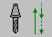
With the key, it is possible to access a submenu that allows the insertion, in the line immediately following the active one (selected by the cursor), of one or more blocks corresponding to the fixed cycle desired.
The submenu, arranged on two levels, because of the high number of available cycles, has the following appearance:

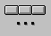
There pressing the key the following second level menu will appear:

Please refer to the Programming Manual Code 720P395 for every detail pertaining to the available cycles; we limit ourselves here to listing some notes of a general nature:
- Pressing a key associated with any Fixed Cycle will make an explanatory image and a Data Entry containing the parameters associated with Cycle appear.
- The Data Entry can be scrolled using the keys [↑], [ ↓], [TAB] and [SHIFT+TAB].
- For a more immediate comprehension, the image, as the cursor scrolls over the various fields, will show the parameters as they are associated.
- The management of the scanning is such that, having reached a field associated with a parameter, for the Cycle selected, compulsory, the user will be forced to fill in the field before being able to continue further.
- The Data Entry will be closed once all the compulsory fields have been completed, by pressing the ENTER key. This will cause among other things the corresponding block to be entered in the programme in editing.
- The operation can be aborted, without entering any block into the programme, by pressing the ESC key.

When the key is activated, if the cursor “is pointing” on a line containing a block that already describes a Fixed Cycle, the Data Entry associated with it will be immediately opened with the fields initialized with the values set in the block. This is extremely effective if one wants to modify, with the Wizard, one or more parameters associated with a cycle already present in the Part Program.

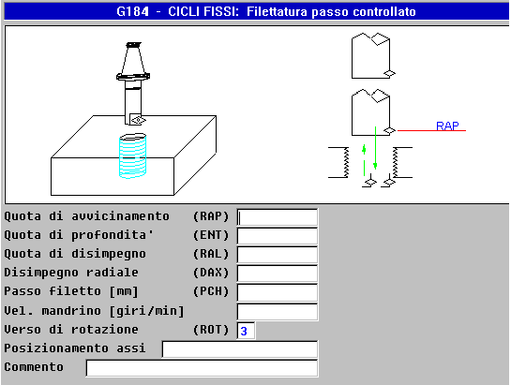
FIG. 5-2 Data Entry associated to fixed cycle(G184) FISSO

The “Macro selection”
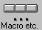
With the key it is possible to access a submenu that allows the insertion, in the line immediately following the active one, one or more blocks corresponding to a macro or one of the many instructions available in the CNC Series WIN.
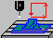
Starting from the SW V3.02 release, the submenu is organized on several levels. The first level submenu has the following appearance:
Submenu selection Macro


By pressing the key it is possible to enter, in the Part Program in editing, all those macros that generate sequences of holes (aligned, arranged in matrix or on an arc of circle) or the milling of sequences of characters. It activates in fact the following menu:


By pressing the key it is possible to enter, in the Part Program in editing, all those macros relative to the emptying/finishing of circular pockets (internal or external), rectangular or slotted with various emptying and finishing techniques. It activates in fact the following menu:
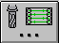
By pressing the key, it is possible to enter in the Part Program in editing, the macros relative to the emptying and finishing of pockets characterized by a generic profile as well as the profiles relative to the processing of three-dimensional surfaces. It activates in fact the following menu:


By pressing the key it is possible to enter, in the Part Program in editing, the macros relative to the measurement cycles with 1-4 movements and qualification probes run with On/Off tracer installed on the spindle. It activates in fact the following menu:

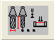
By pressing the key it is possible to enter, in the Part Program in editing, the macros associated with the automatic preset cycles of the tool length. In particular, Macro G211 which uses a fixed position probe, and the preset cycles with the Laser reader. Macros that can be activated through the following menu:

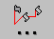
By pressing the key it is instead possible to introduce, in the Part Program in editing, the macros relative to the application of Static Matrixes which translate, turn around a point or an axis, rototranslate, and change the scale of a profile. It activates in fact the following menu:


By pressing the key it is possible to enter, in the Part Program in editing, the macros relative to the application of Dynamic Matrixes capable of rotating a profile around one or more axes or of programming in cylindrical coordinates. It activates in fact the following menu:

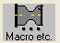The key , enabled exclusively with the option Digitalization unlocked, permits the entering, in the Part Program in editing, the various types of scans scheduled (for greater detail please refer to the manual “Operating Instructions Digitalization Option” Code 720P402).

They key , enabled exclusively with the Milling-Lathe option unlocked, allows the introduction, in the Part Program in editing, of a whole series of turning macros through the menu below:

For more details on these macros, please refer to the Programming Manual CNC 1802 / 4802 Code 720P417).
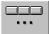
Lastly, by pressing the key, it is possible to enter in the Part Program in editing certain general LIP instructions such as the definition of the Contouring Plan and the axis on which to apply the fixed cycles, the setting of the SW limits, offset origins, machine allowance, mirroring, etc. It activates in fact the following menu:

We remind you that, with the SW tool “MacroMenuDev” it is possible in a completely guided manner to totally reorganize the “Macro” menu supplied by ECS eliminating the recalls to macros considered unnecessary and adding new ones.
For greater detail on how to proceed, please consult the specific manual Code 720P405.
Instead, please refer to the “Programming Manuals” Code 720P395 (Milling) and Code 720P417 (Lathe) for every detail pertaining to the Macros supplied standard by ECS and to the “Advanced Programming Manual” Code 720P396 as regards lastly the acquisition of all the instruments necessary for the realization of new Macros.
Similarly to what was already written for the Fixed Cycles:
- Pressing a key associated with any Macro will make an explanatory image and a Data Entry containing the parameters associated with the Cycle appear.
- The Data Entry can be scrolled using the keys [↑], [ ↓], [TAB] and [SHIFT+TAB].
- For a more immediate comprehension, the image, as the cursor scrolls over the various fields, will show the parameters as they are associated.
- The management of the scanning is such that, having reached a field associated with a parameter, for the Macro selected, compulsory, the user will be forced to fill in the field before being able to continue further.
- The Data Entry will be closed once all the compulsory fields have been completed, by pressing the [ENTER] key. This will cause among other things the corresponding block to be entered in the programme in editing.
- The operation can be aborted, without entering any block into the programme, by pressing the ESC key.
When the key is activated, if the cursor “is pointing” on a line containing a block that describes a Macro, the Data Entry associated with it will be immediately opened with the fields already initialized with the values set in the block. This is extremely effective if one wants to modify, with the Wizard, one or more parameters associated with a macro already present in the Part Program.
FIG. 5-3 illustrates an example of Data Entry associated with the macro FORFLA (FORatura FLAnge-Flange Drilling).

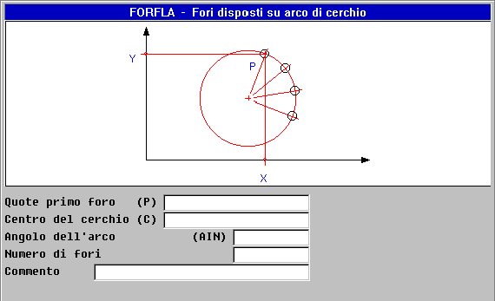
FIG. 5-3
Example of Data Entry associated with the Macro “FORFLA”

Selection “Geometric Help”


With the key it is possible to easily program profiles, in the contouring plan, using the powerful geometric language EXPERT.
For greater detail on the capabilities of the language, we recommend the reader consult the Programming Manual Code 720P395.
In this paragraph, instead, we described the assistance available to the programmer.
With the Geometric Help, the following menu is activated:

Definition  Point | Definition  Line | Definition  Circle | Insert  Bevel | Input  Connection | Set  Limits | Code &  Show | C. & S.  Commands | Switch  Format | Exit
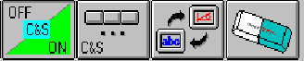
While the keys to one side here will be described later, let us review the remaining ones:

Definition of a “Point”

It allows defining in guided mode a “Point” object choosing from among one of the 5 possible definitions:
- Directly through the Cartesian coordinates (P.. = X..Y..)
- As intersection between two Lines (P.. = L... L ... )
As intersection Line-Circle (P.. = L.. O..
- As intersection Circle – Circle (P.. = O.. O..)
- As centre of a Circle ( P..= O..)
This will be possible by operating in the following submenu:



By pressing, for example, the key the operator does not have to compile the following Data Entry:

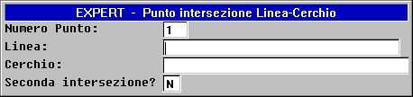
FIG. 5-4 Data Entry “Definition Point”

Definition of a “Line”

It allows defining in guided mode a “Line” object choosing from among one of the 9 possible definitions:
- Connecting 2 Points (L..=P..P..)
- Passing through a Point and inclined at a certain angle (L..=P..RC..)
- Passing through a Point and tangent to a Circle (L..=P..O..)
- Tangent to a Circle and passing through a Point (L..=O..P..)
- Tangent to two Circles (L..=O..O..)
- Parallel to another Line (L..=L..D..)
- Parallel to another Line and passing through a Point (L..=L..P..)
- Perpendicular to another Line and passing through a Point (L..=L..P.. PE)
- Tangent to a Circle of tilt given (L..=O..RC..)

This will be possible by operating in the following submenu:


By pressing, for example, the key the operator does not have to compile the following Data Entry:

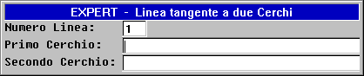
Fig. 5-5 Data Entry “Definition Line”

Definition of a “Circle”

It allows defining in guided mode a “Circle” object choosing from among one of the 15 possible definitions:
- Of known Centre and Radius (O..= G2/G3 I..J..R..)
- As connection between two Lines (O..=L.. R.. L..)
- As connection between a Line and a Circle (O..=L..G2/G3 R..O..)
- As connection between a Circle and a Line (O..= O.. G2/G3R.. L..)
- As connection between two Circles (O..= O..G2/G3R.. O..)
- As connection between a Point and a Line (O..= P.. R..L..)
- As connection between a Line and a Point (O..=L..R..P..)
- From known Centre and Tangent to a Line (O..= I..J..L..)
- From known Centre and Tangent to a Circle (O..=I..J..O..)
- From known Centre and passing through a Point (O..= G2/G3 I..J..P..)
- Concentric to other Circle (O..= O..D..)
- From known Radius passing through 2 Points (O..= P..G2/G3R..P..)
- As connection between a Point and a Circle (O..=P..G2/G3R..O..)
- As connection between a Circle and a Point (O..=O..G2/G3R.. P..)
- Passing through three Points (O..=P..P..P..)
This will be possible by operating in the following submenu at two levels:

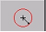


By pressing, for example, the key , the operator will only have to complete the following Data Entry:
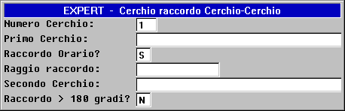
FIG. 5-6 Data Entry “Definition Circle”

Set Bevel

It allows a bevel to be entered between two secant lines.
The operation should normally be run after the definition of the profile.

Set Connection

Permits the introduction of a connection of radius datum between:
- Two secant Lines
- A Line and a secant Circle
- Two secant Circles

The operation should normally be run after the definition of the profile.

Setting Graphic Limits

Allows the limits to be set for the area that will be displayed in “Just Graphics” and “Graphics + Text” format. This is possible simply by filling in the Data Entry shown in FIG. 5-7. In this structure by the term “DRZ..” we mean the direction of the axis. In a Cartesian system DRZ1 → X, DRZ2→Y and DRZ3→Z.

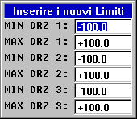
Closing with [ENTER] the compilation of the Data Entry, the instruction LIP<LIM will be entered in the active line: -Xmin; Xmax; Ymin; Ymax; Zmin; Zmax> which in fact makes these limits operating.
FIG. 5-7
“Setting Graphic Limits”
By pressing [ESC], the operation will instead be aborted.

Suggestions for a correct use of the Geometric Help
After implementing the “Geometric Help” selection we recommend:

- Setting appropriately the “Graphic Limits” with the key
- Setting the contouring plan G16.....(For how to operate in guided mode see Paragraph 5.4).
- Selecting the appropriate view (As described in Paragraph 5.14).
- Entering all the necessary, technological-type instructions.
- Going to the line where one intends to enter the new virtual element.
- Activating the key combined to the object that one intends to define (for example a circle of known centre and radius). The CNC will automatically move into Code & Show mode (in Continuous Execution) activating, if not already selected, the “Graphics + Text” format. The graphic representation of the object will appear on the screen depicted blank with the name assigned to it (P.. L… or O..).
In the case of Lines or Circles, the representation will also have the direction.
- Repeat the preceding operation for the objects necessary to define the profile.
- The graphic support of the EXPERT will take care of proposing, by analysing the elements already defined, the index to be attributed to the new object and eventually to inform whether there exist errors, in the program portion already written.
- Insert the instructions of approach to the piece and, should one want to work with active compensation, of connection (G41, G42, G47, G48).
- The profile is thus described as one goes along listing the objects involved. Since the Code & Show mode is entered, it will be noted that the elements involved will change on the screen, first in colour (from white to yellow), then, once the tangency or intersection points have been resolved, the profile will appear (both tool centre and compensated).
- Enter the instructions for disconnection (G40 or G46) and the technological blocks, for disengagement and for closing program (M2).
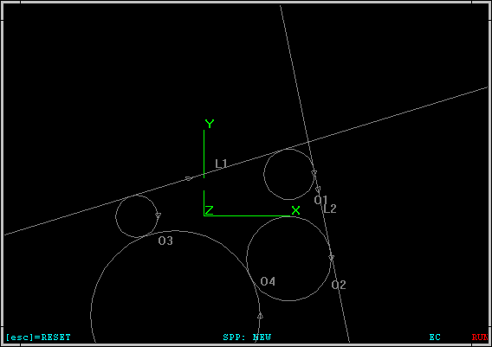
End of the definition of the necessary Virtual Objects.

Representation
In format “Just Graphics”

FIG. 5-9

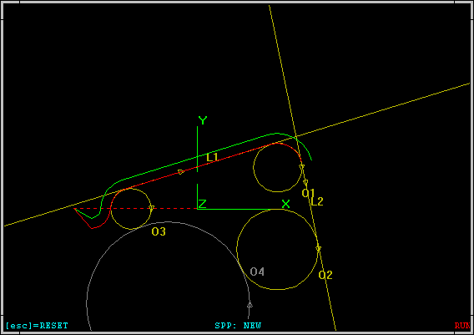
Start of the definition of the Profile

Representation
In format “Just Graphics”

FIG. 5-10

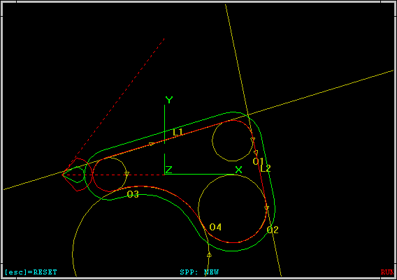
Definition of the Profile finished

Representation
In format “Just Graphics”

FIG. 5-11

Selection “Editing Commands”
By pressing the key, the submenu is activated:

Where the function keys assume the following meaning:

Skip to line N.
Permits the “skip” to the line specified by the operator.

Search String
Permits the search, within the file being edited, of the first recurrence of a string specified by the operator.

Repeat Search String
Repeats the search “triggered” with the preceding command.

Replace String
Allows searching, within the file being edited, for a string replacing it with another one. Obviously both the text searched and the one replaced are defined, through specific Data Entry, by the operator.

Copy
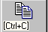Allows to copy in the transit buffer of the Editor the text selected with the combination of keys [Shift] [↑] and [Shift] [↓].

Cut
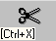Eliminates the text selected through the combinations of keys [Shift] [↑] and [Shift] [↓]. At the same time, the text is saved in the buffer memory of the Editor.

Paste
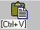Allows to copy, immediately after the line that is currently active, the content of the buffer memory of the Editor.

Open second File
Allows a second File to be opened in Editing. The selection is done with the same methods and help already described for the opening of the first File.

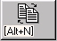
Switch File
Allows the Editing window to switch between the first file and the second one eventually opened with the preceding command.

Close File
Allows the File currently open to be closed. The command is important only when working with two files open at the same time. Should changes have been made, before closing, confirmation will be request as to whether the copy in memory should be updated.

Selection “Operations on File”

By pressing the key, the following submenu is activated:

Save Changes Made
Allows saving in the HDU of the CNC the current content of the File in editing.

Save Buffer on File
Allows to save on a File, defined by the operator, the content of the buffer memory of the Editor (that is to say the portion of file selected with [SHIFT] + [↓] and [SHIFT] + [↑] ).

Insert Content of a File
Allows the content of a specified file to be entered immediately after the active line. The selection of the file to be entered will be done according to the methods of “Selection File” already described.

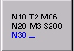Activate Automatic Numbering
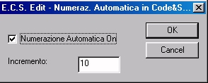
Allows the activation in Editor and in Code & Show the automatic numbering of the block entered by setting the extent of the increase through a specific data entry (FIG.5-12).
FIG.5-12
Data Entry “Setting Automatic Numbering and extent of the increase”

While in Code & Show, when the feature is enabled, the number N. (address) is automatically entered every time a new program line is attached, in Editor the numbering is active also when one is in the program. In this case it will in fact be sufficient to go to the end of the current line and press [ENTER] for a new line to come, entered immediately afterwards. At the address of this line a unit increase will however be automatically applied, regardless of the one preset. This will occur until the N of the subsequent block is greater than the number generated in this way. If the automatic numbering is activated in a non numbered Part Program, at the first block entered the address N0 will be assigned instead.

Renumbering Part Program
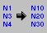This command allows the automatic renumbering of the Part Program in editing. The operator is asked to enter the renumbering step desired. The operation is also run on barred lines and placed as comment. Operates also on instructions <JMP:...>, < IFF ... :N..;N..;N.. > and <RPT: N..; N..> etc.

Access “MANUALE.FIL” File
This selection allows someone to open in editing, parallel to the file selected, MANUALE.FIL, that is to say the file that “records” all the commands that the Operator issues in MDI.
This can become extremely useful both for transferring in the Part Program selected operating sequences previously verified step by step in MDI, and vice versa for “initializing the buffer” MANUALE.FIL with a specific sequence of instructions. Remember that the MANUALE.FIL file is located in ECS.CNC\LAV\WORK, in a directory therefore not directly accessible.

Print File

Prints, on the printer configured and connected to the parallel port of the CNC, the File in Editing.

Display Tools Table
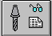
This selection displays the Tools Table of the CNC, basically to define the tool that one intends to use without having to leave the editing of the Part Program. For details on the display see Chapter 8.

Display Origins Table
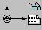
This selection displays the Origins Table of the CNC, basically to define the tool that one intends to use without having to leave the editing of the Part Program. For details on the display see Chapter 9.

Selection “Edit Help”
Pressing the key makes the Help window appear shown in FIG. 5-13. Window which will disappear by pressing [ESC] or [ENTER].
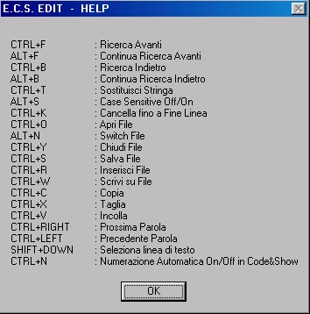
FIG. 5-13
Editor Help Window

Selection “Code & Show”
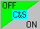
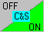
Two distinct icons are associated with this toggle switch key:
Which indicate that the Code & Show mode is Enabled or Disabled.
The Code & Show mode allows the processing and relative graphic representation of the Part Program in Editing.
By enabling the mode, the screen, if it was not already in “Graphics Only” or “Graphics + Text”, will automatically switch to “Graphics + Text” format. The Editor of the CNC in fact allows the screen to be run in three distinct modes:
- Text Only (Default setting when entering into Editor),
- Graphics + Text (the Graphics take up about 2/3 of the upper part of the screen available),
- Graphics Only (feature which can used as an alternative to the zoom in order to better analyse the profile generated)
To switch between the various formats, a specific key is used (See Paragraph 5.11)
The Part Program in editing will be interpreted and its graphic representation shown on the screen. Eventual errors will interrupt the interpretation and therefore the graphic representation. In this case an appropriate alarm will appear on the screen and the line of Program containing the error will be highlighted. The Code & Show mode will moreover be automatically suspended (OFF status).
If instead no errors are encountered, it will remain enabled (indication “RUN” in red on the last line of the graphics window). In these conditions, as the operator introduces new program lines, the graphic result of their execution will be shown on the screen as well as the eventual error signal which again will place the Code & Show mode in OFF.

Having made the necessary correction, by pressing the key again the mode will be reactivated and the graphic representation completely reconstructed. It must be noted in fact that this entails a complete re-execution of the Part Program in editing.
Notes:
- Ultimately, the Code & Show mode represents a powerful debug tool of a Part Program. Debug which can in any case be elaborated through the “Graphics Simulation” mode described in Chapter 6 of this Manual.
- Should the Part Program contain GAP instructions, during its compilation with “Code & Show”, at the beginning of a line of program an immediate graphic result may not correspond since the interpreter could require additional instructions before setting up all the geometric data necessary for the identification of the profile programmed.

Selection “Code & Show Commands”

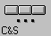
By pressing the key, the following submenu is activated:

Where the function keys assume the following meaning:

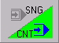
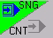
Continuous/Single Execution
Two different icons are associated with this key: In fact it allows the Part Program to be run in either Continuous or Single mode. The symbol shown in green is the one corresponding to the active mode.

Select Variables
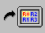
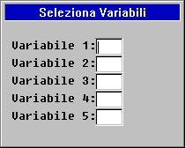
It opens a Data Entry with which up to 5 variables “R” can be defined, the value of which will be displayed in the top left corner of the screen during the verification of the program in “Code & Show”.

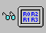Display Variables
If pressed with Code & Show enabled, it either Enables/Disables the display of the 5 variables R previously selected.

Management Tools
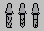
Activates the submenu “Management Tools in Graphics Environment” described in detail in this Chapter in Paragraph 5.13.

Management Origins

Activates the submenu “Management Origins in Graphics Environment” described in detail Paragraph 6.7.2.

Selection Views
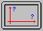
When the Code & Show function is disabled, activate the submenu “Selection Views” described in detail in this Chapter in Paragraph 5.14.

Enable/Disable Code & Show
Enable/Disable the Code & Show mode already described in Paragraph 5.9.

Set Graphic Limits
Allows the limits to be set for the area that will be displayed in “Just Graphics” and “Graphics + Text” format. Command already described in Paragraph 5.5.6.

Search Graphics

This key is enabled only if on the screen the graphic relative to the Part Program is already displayed and one is in “Graphics + Text” mode with “Code & Show” disabled.
It allows, through a cursor controlled by the arrow keys, any section of the profile to be selected. Once the cursor is position around the element desired, by pressing [ENTER] a search in the Part Program for the line to which this element is associated will be enabled. At this point with the keys [↑] and [↓] it will be possible to scroll through the contiguous elements of the profile, following at the same time on the Part Program the lines that define them.
The operation ends by pressing [ESC].
The function is extremely useful when one wants to make changes to a section of profile. Once the line of program has been identified which is associated with that particular element of the profile, it is in fact possible to make the desired changes to it and then reactivate the “Code & Show” mode to verify its effect.

Cancel Screen
Allows the content of the Graphic Database which the CNC uses for the previously described function of Search Graphics to be cancelled together with the screen.
The function is enabled exclusively with “Code & Show” disabled.

Selection “Switch Format”
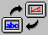
By pressing the key it is possible to switch in a revolving manner between the various formats of the Editor environment, that is to say: “Text Only”, “Text + Graphics” and “Just Graphics”.

Selection “Exit Editor”
By pressing this key, one exits the Editor environment. The operator will be asked if he wants to save or not the changes possibly made to the File in Editing.

Management Tools in Code & Show / Graphics Environment
In this paragraph is described the management of the Tools Table used in the Graphics environment. On this structure, completely distinct from the similar one used in CNC environment, it is possible:
- To insert a new Tool
- To modify a Tool defined there.
- To save the current contents of the Tools Table onto a File.
- To load all the tools with the values stored in a File.
- To initialize the Tools Table of the Graphics environment with the content of the one currently enabled in CNC environment.
- To cancel from the active table one or more tools.
- To cancel one or more Tools Files.

Notes:
- It is worth noting that in the Graphics environment, as well as in the CNC environment, 256 Tools/Controls can be defined.
- The files used to save the tools assume the extension .TOG. These files can among other things be used to import a set of tools defined through the “Videographic” simulation SW Off-line.
- To create a better representation, in particular in simulation, the operator can combine a form and a colour at his pleasure to each tool.
- In the Graphics environment, the insertion of Controls (D) into a table is also scheduled. It being improper to define the shape and the colour of a control. During graphic simulation a control will continue to maintain the shape and the colour of the tool previously selected. Obviously radius and length will however be updated as a result.
- It is important to note that the Graphics Environment operates, as it relates to the Tools Management, as if the tools machine were equipped with a Manual Tool Change. This regardless of C.U. actually present.

By pressing the key, the following submenu is activated:

Insert  Tool | Insert  Corrector | Change  Tool/  Control | Save  Tools  Table | Load  Tools  Table | Load  ToolsCNC | Save  File  Tools | Cancel  Tools/  Controls | Cancel  File  Tools

Where the function keys assume the following meaning:

Insert Tool
Allows the data of a new Tool to be entered. Automatically this involves the opening of a Data Entry (FIG. 5-15).
In this structure, as usual, one moves from one field to another using the keys [TAB], [SHIFT+TAB], [↑], [↓], and the editing is closed with the key [ENTER].
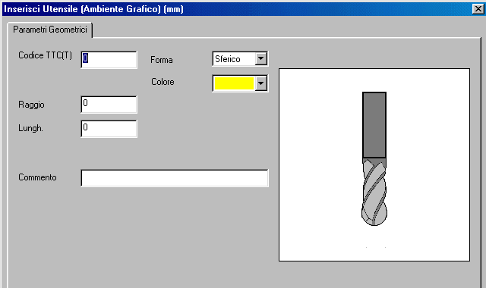
FIG.5-15
Data Entry ”Insert New Tool”

In sequence, the operator will be asked to complete the following fields:
- “Tool Code”
Represents the Logic Type Code (TTC or T) of the tool (or corrector), that is the number associated with it in the Part Programs. We remind you that the Tools Table can contain at most 256 elements (between Tools and Correctors), while the maximum number that can be set as code T (TTC) is 65536.
- “Shape”
The “Shape” field, not important for the Correctors that continue to assume the shape of the tool to which they apply, is used in the “Simulation Graphics” environment to display correctly the tool during the processing. In this field the following choices are provided which can be activated using the keys [↓] and [↑]:
List of Shapes that can be associated with a Tool
Spherical | Spherical Milling
Cylindrical | Cylindrical Milling
Toroidal | Toroidal Milling
Point | Point
Male | Male
Probe | Tracer
- “Colour”
This field is also used exclusively in the “Simulation Graphics” environment typically to highlight sections of profile run with different tools.
By using the [↓] key in this field, the standard Windows® structure will open as in FIG. 5-16. To select the colour desired among those shown, operate as follows:
- With the keys [↓], [↑], [←] and [→] scroll through the structure until the desired colour is reached.
- With the [TAB] key we go to the field [OK].
- With the [ENTER] key the colour selected is confirmed.
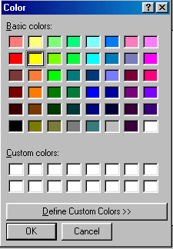
FIG. 5-16
Table “Selection Colour Tool”

Notes:
- The Structure of FIG.5-16 allows customized colours to also be defined.
- The default colour is yellow.
- Colour has no meaning for the correctors which continue to be represented with the same colour as the tool to which they are applied.
- “Geometric Parameters”
The operator must then define the Radius and the Length of the Tool. The unit of measurement to be used (mm or inch) is given not encoded in the heading of the Data Entry and depends on how the CNC was configured.
- “ Comment”
In this field, the operator can enter a description of the tool up to a maximum of 40 characters.
To speed up the definition of several tools, once the data associated with the first one have been entered, the Data Entry is automatically reopened. Also in case of error, the Data entry is automatically reopened but with the last data entered while on the CNC an appropriate warning message will appear issued by the Tool Controller. Finally, with the [ESC] key it will be possible to end the operation.

Insert Corrector
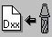Similar to the preceding description “Insert Tool”, it allows a new Corrector and all the data associated with it to be entered. Automatically this involves the opening of a Data Entry (FIG. 5-17).

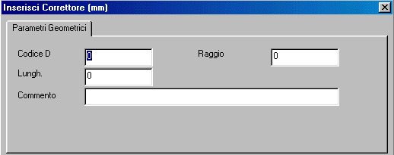
FIG.5-17
Data Entry
“Insert Corrector”

Also in this structure one moves from one field to another using the keys [TAB], [SHIFT+TAB], [↑], [↓], and the editing is closed with the key [ENTER].
In this case as well, once entering of the data associated with the Corrector is finished, a new Data Entry will open automatically to allow the eventual insertion of other data. It will be possible to abort the operation with the key [ESC].

Change Tool/Corrector
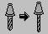
This selection allows the parameters associated with a Tool or a Corrector to be changed, after having selected it by scrolling through the Tools Table represented by the structure shown in FIG. 5-18.
As can be seen in this structure, the Tools/Correctors are arranged progressively depending on the code. The scrolling down the table is done with the vertical arrow keys [↑], [↓], [PGDN], [PGUP], [HOME] and [END]. With the keys [←], [→] it is also possible to scroll the single line to access the fields possibly not directly visible
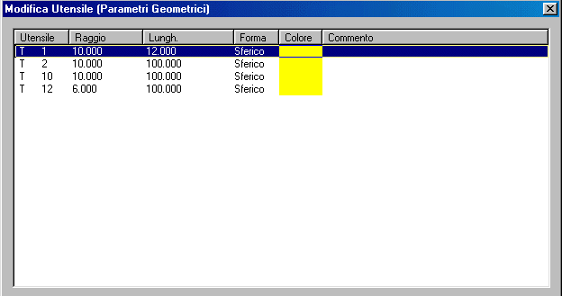
FIG.5-18
Table Tools

Note that the fields associated with table can be freely configured using the mouse. The configuration done in this way is then stored in the file C:\ECS.CNC\WINVIS\ECSTOOLS.INI and automatically reactivated at each subsequent access to the structure.
Once the tool/corrector to be modified is selected, by pressing [ENTER] a window appears which contains in “compact” form all the data relative to it (FIG. 5-19).
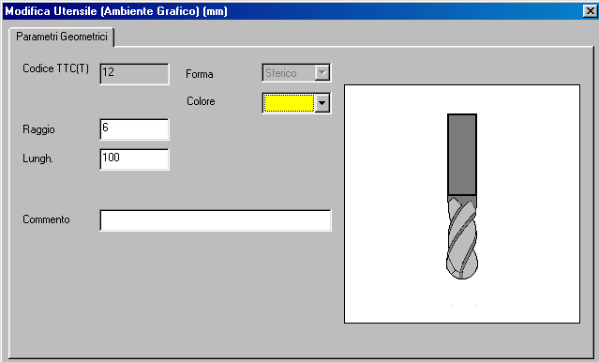
FIG.5-19
Change Parameters Tool

As can be seen, in the structure of FIG.5-20 it is possible to modify the fields “Geometric Parameters”. “Colour” and “Comment”.
Instead the “Code” and the “Shape” of the tool cannot be altered.
Having made the modifications desired with [ENTER], the changes will be made operative.
To speed up the modification of the parameters of several Tools/Correctors, the SW, once the update is concluded will return automatically to the Tools Table, in selection phase. To end the operation, it is only necessary at this point to press [ESC].

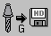
Save Tools Table
It entails the saving onto a FILE, resident in the sub directory WORK of LAV (or F:\LAV in case of active network option), of all the data associated with the tools currently present in the Tools Table of the Graphic Environment. In fact, the entire table VT.BIN is saved in a file with the extension .TOG.
The save is done in completely guided format by compiling the Data Entry shown in FIG. 5-20
FIG. 5-20 Data Entry: “Save Table Tools”

Pressing [↓] in the field “NAME FILE” the operator will be presented with a list of all the files with extension .TOG already present in the directory WORK of the CNC. Having selected an already existing file, or having keyed in a new name (max 8 characters) by pressing [ENTER] the save operation of the Tools Table valid exclusively in Graphics environment will be completed.

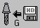
Load Tools Table
It allows the data relative to a set of tools previously saved with the command “Save Tools Table” to be loaded into the Tools Table VT.BIN.
The loading is done in complete guided format. First the structure will appear shown in FIG. 5-21, then by pressing [ENTER] the operation will start.
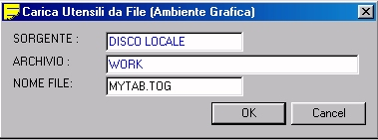
FIG. 5-21 Data Entry : “Load Table Tools”

The “Load Tools” operation implements a complete substitution of the table VT.BIN previously enabled. In fact, it is as if all the tools previously present were cancelled or replaced by those contained in the file selected. For this reason, the CNC asks for confirmation before proceeding.

Load CNC Tools
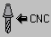
Initializes the Tools Table of the Graphics environment with the tools currently defined in CNC environment. The field “Colour”, not defined in CNC environment, is initialized with yellow (default colour).

Save Tools File
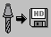It entails the saving onto a FILE, resident in the sub directory WORK of LAV of all the data associated with the tools currently present in the Tools Table of the “Graphics Simulation” Environment. In fact, a Part Program is generated capable of “loading” in the CNC the geometric data of these tools (Code T, Radius and Length). The save is done, in completely guided format, by compiling the Data Entry shown in FIG. 5-22.

Notes:
- The file will be given the extension .TOL.
- The File will be exclusively generated when the Tool Change defined in CNC environment is the Manual type since only in this case will it be congruent and therefore exportable. Otherwise the key will in fact not be enabled.
Pressing [↓] in the field “NAME FILE” the operator will be presented with a list of all the files with extension .TOL already present in the directory WORK of LAV. Having selected an already existing file, or having keyed in a new name (max 8 characters) by pressing [ENTER] the save operation of the Geometric Data of the tools defined will be completed.


Eliminate Tools/Correctors
It allows one or more Tools/Correctors defined in the active Tools Table to be eliminated.
In this case as well, initially the element or the elements that one wants to eliminate must be selected from the Tools Table. This will be possible by operating in the Tools Table as already described in Paragraph 5.13.3. The selection/deselection of the tools will take place instead with the keys [CTRL] + [SPACE]. The real elimination phase will be triggered by pressing the key [ENTER]. The operator will be asked to confirm before proceeding.


Eliminate Tools File
Allows one or more tools files (characterized by the extension .TOG) to be eliminated from the work directory of the CNC.
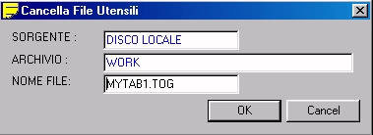
FIG. 5-23 Data Entry: “Eliminate Tools File”

By pressing the [↓] key in the field “NAME FILE’ it will be possible to scroll through the entire list of the Tools Files located in the sub directory WORK of LAV and then with the key [CTRL] + [SPACE] to either select/deselect the files desired.
The real elimination phase will be triggered by pressing the key [ENTER]. The operator will be asked to confirm before proceeding.

Views and Zoom
This selection allows the view to be defined in which one wants to view the image. As well as to enable/disable the “ZOOM” and “REDRAW” features
By pressing the key, the following submenu is activated:
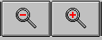

Where the function keys assume the following meaning:

View 12
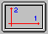
Selects the plan view (represented on the Cartesian plane formed by the axes of Direction 1 and Direction 2, normally XY, G16XY or G17).

View 31
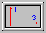
As in the preceding case but on the plane identified by the axes of Direction 3 and Direction 1, normally ZX, G16ZX.. or G18.

View 23
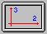
As in the preceding case but on the plane identified by the axes of Direction 2 and Direction 3, normally YZ, G16YZ.. or G19.

View ISO standard
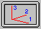
Selects a three-dimensional default view (ISO standard)

View ISO Mirror
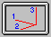
Selects a three-dimensional view arranged in mirror mode compared to the previous one.

Customized View
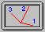
Allows a customized three-dimensional view to be defined. The selection of this option displays a right-handed triad of axes that can be rotated using the arrow keys. Having reached the desired perspective view, pressing the key [ENTER] will refresh the graphic in conformity with this orientation.

Redraw

Refreshes the screen image. Can be useful for “cleaning” the image after the cancellation or the modification of the geometric or technological data.

Zoom

This selection allows the graphic representation of the Part Program selected to be scaled down in order to bring it totally within the screen.
It is therefore useful to bring back onto the screen objects which, after using Zoom + (See later) or during an incorrect set-up of the Limits and gone off screen.
The selection of this item enables a new submenu which includes the following selections:

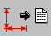
Geometr.

Technologic |  |  |  |  |  |  | Geometric |  | Insert  Limits

Geometric Zoom
It automatically brings back the whole profile within the screen without taking into account possible rapid disengagement movements of the tool.

Technological Zoom
Like the preceding one but taking into account also any rapid movements of the tool.

Insertion Limits
It allows the current limits to be introduced, in the form of the instruction <LIM:…..>, in the second line of the program in simulation (the one that follows the character %).
Considering that Zoom – command physically modifies the active limit, this command can be used to save permanently a “scale” which permits the entire profile to be visible.
If the <LIM:…> instruction is already present (placed right after the character %) it will be appropriately modified. Instructions <LIM:…> placed within the program will instead not be eliminated or modified.

Zoom +

This allows a rectangular zone of the screen to be enlarged using the following mode:
Place the cursor on the lower top left of the window and press [ENTER] (or click on the left key of the mouse) to store this point.
Using the key [→] (or holding down the left key of the mouse) the window can be opened at the desired size.
The next activation of the key [ENTER] (or by releasing the left key of the mouse) the desired size of the area highlighted will be activated.

PPGM – Environment “Simulation Graphics”
From the main menu, using the key PPGM the Simulation Graphics environment of the CNC is activated.
Within this environment, it is possible to perform the graphics simulation of the tools paths programmed by activating a whole series of powerful graphic utilities (Possibility of defining origins of reference, scale factors, Zoom, standard and customized views, etc.). It is further possible to describe a “Rough”, that is to say a profile that allows a better comparison between what one wants to obtain as processing on the Machine and the original semi-processed product. This methodology is further useful, for example, to verify the overlaps of the removals, the simulation of the clamps and blocks and therefore in general the analysis of the obstructions and the collisions.
It allows the distance (in the space) to be know between two points of the profile displayed (not necessarily belonging to the same element) as well as to go back from a graphic element of the profile to all the information associated with it (name of the program and number N of the Block, compensated coordinates and not of the end points of the element etc.).
Please note again that, similar to what occurs with the Editor, all the services available in this environment do not interfere with the operation of the Numerical Control and can therefore be used also while the tool machine is working with a different Part Program.
In the Graphics Environment in fact the same “Tools Table” and “Origins Table” already illustrated when describing the Editor are used, that is structures different than those active in the CNC environment.
Starting from the release SW V3.02, the possibility was reintroduced, already present in the CNC Series 2400, of loading, when entering the Graphics environment, the same Origins and Tools available in the CNC environment.
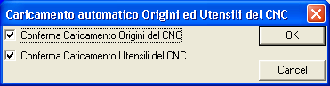
Through a special calibration in the file GEN.TAR (field CTOI=Y) when entering Graphics the window will appear on the screen as illustrated in FIG.
FIG. 6-1
Request alignment tools and origins between Graphic and CNC environment
6-1 will allow the operator to select what to transfer (Origins and Tools, just Origins, just Tools, nothing).

As regards the tools, the transfer, if enabled, will operate in 2 phases. First all the pre-existing tools will be eliminated from the table (of the Graphics environment) then all the CNC tools will be loaded. The possibility recently introduced to define also in the CNC environment the colour associated with each tool allows this property not be lost during transfer.
When entering the “Graphics Environment” the ten function keys F1-F10 assume the following meaning:

Select  Program | Execution | Switch Environment  CNC | Animat. | Set  Limits | Views | Other  Selections | Edit | Cancel | Exit

Selection Part Program

This function permits the selection and the loading into memory of the Part Program that one wants to simulate graphically.
This is possible by working in the Data Entry illustrated in FIG. 6-2.
The Program must be located in the directory LAV of the hard disk of the CNC (or in the remote Hard disk, in case of network option).
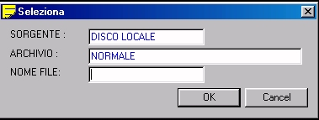

By pressing the key [↓] in the field “NAME FILE”, the operator is shown a list of all the Part Programs (Files without any extension) located in the work directory of the CNC.
The list can then be scrolled using the arrow keys [↑] and [↓ ] as well as the keys [PgDn], [PgUp], [Home] and [End].

Since the files are stored in alphabetical order, for an even faster access, it is furthermore possible to use their initial character as search key.
For example by keying in [P] the cursor will automatically position itself on the first file of the list with a name starting with “P”.
Once the name of the desired Part Program is identified, to select it simply press [ENTER] 2 times in succession.
The name of the Part Program selected will appear, at this point, at the bottom of the screen SPP: ..... (For greater detail see FIG. 6-3).
Entering the “Graphics Environment” the screen is always cancelled (the Graphics Database of the CNC is in fact automatically reset).
Should an alarm occur in these conditions on the CNC and on the PLC, the inset placed in the bottom right corner of the screen (normally used to show the ECS logo) would turn red indicating the code of the alarm.
In any case, both from PLC and from Part Program, it is possible to send to the screen messages and Data Entry capable of superimposing any active screen, including therefore those of the Graphics environment.
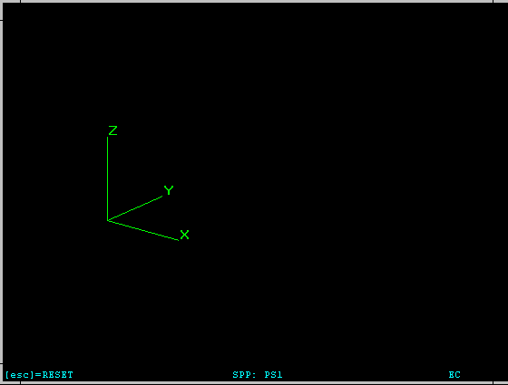
GENERAL CLAUSES
Part Program
Help
FIG. 6-3
Entry into Graphics Simulation Environment

Execution Part Program
This function activates the continuous or step by step execution of the Part Program selected. The execution of the Part Program must precede its simulation since it allows the CNC to construct the Graphic Database on which the Simulation rests. The selection also permits, should the option “Verification Figure” be enabled, to activate the relative environment (application NC Verify).
Pressing the key activates the following submenu:

Execution  Single | ExecutionContinuous | Switch Environment CNC | Stop  Esecution | Cancel | Verify  3D

Continuous Execution

It is sufficient to simply press this key to command the complete graphic processing of the program. Any stops, caused by Stop Program (M00) within the Part Program require, in order to continue the execution, that the [ENTER] key be pressed.

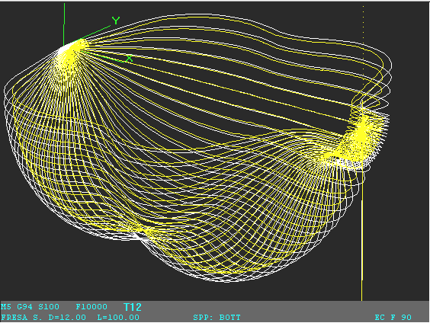
FIG. 6-4

Continuous Execution of a Part Program

Single Execution

This command allows a single instruction of the Part Program selected to be executed at a time. Every time the [ENTER] key is pressed a new line of the Part Program is interpreted. The instruction performed is shown in the bottom left corner of the screen.

Switch to “CNC Panel”
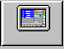
This key allows to momentarily switch the display from Graphics Simulation environment to CNC environment. When an Alarm or a Warning appears, the operator can thus get more information on what happened quickly.
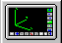
Pressing the key again instead makes it possible to return to the Graphics Simulation.

Stop Simulation
Allows, in particular during the simulation phase of very long Part Programs, to stop the simulation when desired.

Cancel Graphics Database
Cancels from the processing memory and the Graphics Database all the files (Part Program, Subroutines, Macro, Tools, etc.) used, up to that moment, in the graphics display.
The command is necessary when starting to work on a new Part Program, otherwise in fact the new profile would be superimposed on the preceding one.
The cancellation does not occur automatically since in certain cases, when a piece is created in several processing phases (therefore with different Part Programs), the superimposition could be useful. Remember that when entering Graphics Environment the Database is instead automatically reset.

Verification 3D
Allows the Part Program selected to be converted into a format compatible with the “NC VERIFY” Three-Dimensional Graphics Verification environment and consequently to active it. The operations are carried out through the window shown in FIG.6-5.
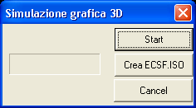
Button start Verification Graphics of the P.P. selected

Button conversion of the P.P. selected in formato “NC Verify”

FIG.6-5 Window“Activation Verification 3D Graphics”

Note:
For greater detail on the SW “NC Verify” see Paragraph 20 of this Manual.

Switch to “CNC Panel”
For details see Paragraph 6.2.3.

“Animation”

This function allows the animated simulation of the tool paths programmed to be executed. In order to work, it requires the presence of the Graphic Database associated with the Program (in other words that the program was carried out previously).
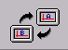
Activates a submenu in which the following selections appear:

Simulation  Sing. / Cont. | Start  Simulation | Reduce  Feed | Increase  Feed | Redraw | Perform from Block | Perform from Tool | Traccia  ON/OFF | Cancel  Restart  Simulation | Switch System Reference

Single/Continuous Simulation
This “toggle” key allows the simulation to be configured in



continuous or single (step-by-step) mode.
In this second case, the execution of each block will be conditioned by pressing the key “Start Simulation”.

Start Simulation

This button activates the simulation. The graphic representation of the tool will reflect the Colour and the Shape given them in the Tools Table (See Paragraph 5.13). Remember that any introduction of a corrector will not modify either the Shape or the Colour of the tool previously used.
The Simulation will respect:
- The Single or Continuous mode set (See 6.4.1.)
- The speed set for the moving of the tool (See 6.4.3.)
- It will start from the Block or from the Tool as requested (See 6.4.5. and 6.4.6)
- Will display or not the outline based on what was set (See 6.4.7)
- Will stop/restart the simulation based on what was set (See 6.4.8)
The simulation will be aborted by pressing [ESC].
Note:
Starting with the SW V3.0 release, during simulation, in the lower left corner of the graphics display area, a series of information will appear relative to the spindle (rotation direction M3/M4, method of work G9x, speed of rotation S... and progress F...) as well as the tool assembled (T.., Length, Radius and any comment)

Reduction/Increase Speed of Simulation

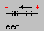
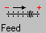
The two keys allow the speed of the tool to be reduced or increased during the simulation. The speed is expressed as a percentage of the maximum sustainable value. Therefore it varies between 10% and 100%. The current percentage value is shown in the lower right corner of the window dedicated to the simulation. Note that the speed in Simulation is not correlated in any way with the actual speed of the tool in operation.

Redraw
This Function refreshes the screen image. It can be useful for “cleaning” the image after the cancellation or the modification of data in the Part Program.

Simulation from Block....

It simulates all the paths of all the tools activated following a specific instruction (Block) of the Part Program. The simulation starts from the specified block and proceeds in continuous or in single mode depending on the mode selected.
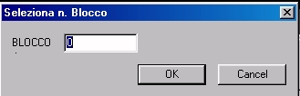
To specify the Block, the operator is asked to complete the Data Entry shown in FIG. 6-6.
FIG. 6-6 Data Entry: “Select N. Block”

Simulation from Tool....

It simulates all the paths of all the tools programmed after the specified tool. The simulation starts from the specified tool and proceeds in continuous or in single operation depending on the mode selected. To specify the tool, the operator is asked to complete the following Data Entry:

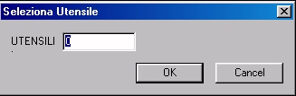
FIG. 6-7 Data Entry: “Select N. Tool”

Track ON / OFF


During the simulation it enables or disables the display of the tool track. By the term “track” we mean the overall dimensions of the tool diameter the length of the profile.

Cancel / Resume Display
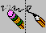
The tool path performed before pressing the key is cancelled. Instead, the next one will be displayed.

Switch System of Reference
Starting from the V3.0 release, it is possible to define 2 distinct Cartesian systems of reference. This allows Part Programs to be displayed correctly in graphic environment, even when they contain processing related to different systems.
The activation of the two configurations is done with the new instruction LIP<SVP:c> where:
“c” = 0 selects the first system of reference (main),
“c” = 1 selects the second (secondary).
During the graphics simulation the instruction <SVP:...> allows the system of reference to be switched dynamically at the same time resetting the display.
In these conditions the key instead allows all the processing associated with the main systems and the secondary one to be displayed alternatively.

Set Graphic Limits
This selection allows the limits of the field of which to be defined that one intends to display. These limits are set through a specific Data Entry with the format illustrated in FIG. 6-8.
FIG. 6–8
Data Entry “Set Graphics Limits”

The values entered represent in mm the maximum displacement that one wants to have represented on the screen for each direction/sense. The values will then be “standardized” based on the dimensions which can actually be used on the screen. Following confirmation by the operator with [ENTER] it is furthermore possible to enter these limits (with the instruction <LIM:....>) in the program selected (immediately after the character %).

Selection View
This selection allows the view to be defined in which one wants to view the simulated profile. For greater detail on this function please see Paragraph 5.14.

Other Selections
This selection controls the opening of the following submenu:
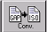

Distance | Origins | Tools | Move Origin  Graphics | Estimate time of  execution | Measurements | Convert  GAP→ ISO | Management  Rough | Select  Variables | Display  variables
The functions gathered here are basically for simulation; let us review them in detail:

Distance
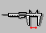
Allows the distance (in space) to be known between two points of the profile displayed (not necessarily belonging to the same element). The points are identified by moving the cursor, with the arrow keys, and confirming the position with [ENTER].
The cursor can select just the outer points of an element. The point is identified by proximity. In addition to the absolute distance, the components on the three Cartesian axes are also provided.

Graphic Origin Management
This selection allows management of the Origins Table utilised in Graphic Simulation environment.
In this case also, as with the CNC environment, 20 origins are anticipated.
Selection activates the following sub-menus:

Edit  Origins | Save Origins | Load  Origins | Activate  Origins  CNC | Reset  Origins | Cancel.  File  Origins

Edit Origins

By selecting "Edit Origins" a window with the active origins table will appear listed in FIG. 6-9.
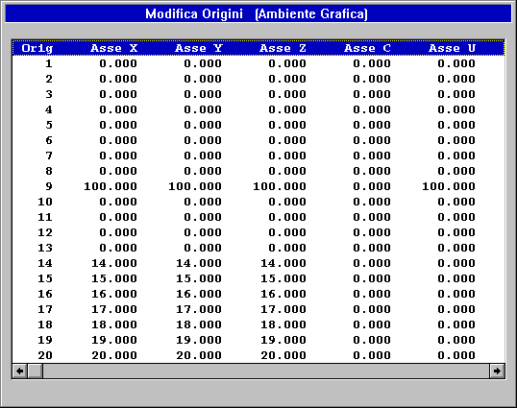
In this structure only the origins relative to the first 6 axes configured are visible initially. With buttons [←] and [→] , the other axes can also be viewed (remember that the CNC 4801 can manage up to 12 axes).
FIG.6-9
"Edit Origins" Table
Graphic Environment

Once the origin has been selected using buttons [↑], [↓] and [ENTER], the user can make the desired changes by acting on the Data Entry shown in FIG. 6–10

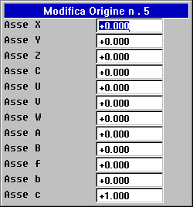
FIG. 6–10 Data Entry “Edit Origins”

Save Origins
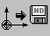
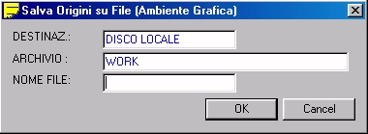
Saving takes place in a completely guided form by filling in the Data Entry shown in FIG. 6–11
FIG. 6-11 Data Entry: "Save Origins"

The CNC will attributed by default the extension .ORI to the destination file.
Upon pressing [↓] in the "FILE NAME" field, the operator will be presented with a list of all the files with the .ORI extension already present in the CNC directory C:\ECS.CNC\LAV\WORK. Once an existing file is selected, or a new name is typed (max. 8 charaters), press the [ENTER] button to save the Origins. Note that this type of file may also be utilised in CNC Environment since the saving format is identical.

Load Origins
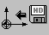
The selection "Load Origins" allows a set of Origins previously saved with the "Save Origins" command to be loaded in the Table.
Upon pressing [↓] in the "FILE NAME" field, the operator will be presented with a list of all the files with the .ORI extension already present in the CNC directory WORK. Once the file is selected, press the [ENTER] button to save the Origins. The operation will be possible by acting on the structure shown in FIG. 6-12.

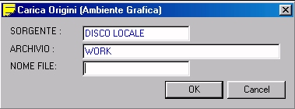
FIG. 6-12 Data Entry: "Load Origins"

Activate CNC Origins
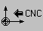
This allows the origins currently utilised in the CNC to be transferred to the Origins Table active in Graphic Environment. The operation is activated only after the operator has given consent.

Reset Origins
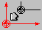
This allows all of the origins in the Origins Table relative to the Graphic Environment to be reset. Before proceeding confirmation from the operator will be requested.

Delete Origins File

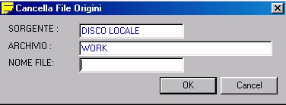
This selection allows one of more Origins files characterised by the extension .ORI to be deleted from the "WORK" directory.
FIG. 6-13 Data Entry: "Cancel Origins File"

Press the [↓] button in the "FILE NAME" field to scroll through the list of Origins files present in the WORK directory and then use the [CTRL]+[SPACE] key to alternatively select/deselect the files which are to be deleted.
The operation will begin by pressing the [ENTER] key and after the user responds affirmatively to the further request for consent.

Tool Management
This allows the Tools Table utilised in the Graphic Environment to be defined / modified.
For more details on this subject see Paragraph 5.13.

Move Origin
This allows the video origin to be moved to a new position within the screen, definable by moving the cursor using the 4 arrow keys or directly with the mouse. The new origin is acquired by pressing the [ENTER] key or by clicking the mouse.

Execution Time Estimate
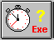
This selection allows the execution time of a Part Program to be estimated with a good approximation.
Once the Part Program is selected (by following the standard method already described in Paragraph 6.1), press the [ENTER] key and the CNC will begin analysis.

At the end of the analysis the following information will be provided:
- Total Execution Time
- Rapid Movements Time
- Auxiliary Functions Execution Time (Mxx).

In order to evaluate the execution time of the Auxiliary Functions M, the CNC uses a specific Calibration file which must be appropriately filled out by the tool machine manufacturer. This file, called MISC.TIM, resides in the C:/ECS.CNC/TAR directory and can be accessed only from the "Service" environment (which requires the Password to be unlocked).

Measurements

This allows, by using the cursor or the mouse, an element of the profile to be selected by proximity.
Once this is done, a series of information relative to the associated instruction will be shown on the screen. In particular:
- The Name of the program which the instruction is part of.
- The "N" of the instruction
- The type of Gxx (Linear or Circular / Work or Rapid)
- The compensated coordinates and not the end points coordinates of the element.
- The coordinates of the centre in case of circle arcs.

Also, using the arrow buttons [↑] and [↓], it is possible to navigate through the contiguous elements obtaining the same information for these as well.

GAP →ISO converter
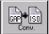This selection allows conversion of the Part Program which is currently selected in which the profile was developed utilising instructions in the proprietary ECS GAP and EXPERT language into a standard type program in which the same profile is realised exclusively with ISO instructions (G1, G2 and G3).
This tool is therefore very useful to "export" programs realised with powerful ECS geometric programming languages onto a machine which is equipped only with other CNC's.
Operation is extremely simple. In fact, it is sufficient to define, in the Data Entry which appears on the screen, using the selection key, the name which is to be attributed to the converted ISO program and to specify the path where it is to be saved (on the local disk or a remote disk in case of a network).
Press [ENTER] and the conversion is executed. At the same time, the program will be re-executed and shown on the screen.

Observations:
- A parametric type program is converted based on the value assumed by the variables in the conversion phase.
- In case of the presence of repetitions (instructions LIP <RPT:...>) the converted program will be "exploded". It could, therefore, increase considerably in size.
- Programs which include conditional instructions such as <IFC:...> may present problems in conversion.
- They are not Matrix (Statistic and Dynamic) and converted macro ECS.

Rough Management
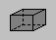
With this selection a "Rough" can be described, or a profile which allows for better comparison between the desired result as processing on the Machine and the original semi-finished product. This method is useful to verify the coverings of the skiving, simulation of the brackets and blocking and therefore, in general analysis, the operating space and collisions. One or more "rough" profiles, usually designed as parallelepipedons, can therefore be added to the graphical representation of the processed surface.
The file describing the rough must be subject to the following rules:
- Its extension must be .GRZ
- It must begin with a special instruction in which, in the same block, two depth quotas appear (the difference of which will be considered as the height of the rough).
- It must contain the description, by means of purely ISO instructions, of the profile of the rough in the design. These instructions must be written with the same rules valid for compilation in a conventional Part Program with the only difference being that they need not include % characters nor the M02 string, nor other non geometric instructions.
Example:
We want to define a cylindrically shaped rough characterised by a base with a radius of 100 mm with the centre of the origin and height (Z) of 300 mm:
Using the CNC Editor, open a new file called TEST.GRZ.
Then introduce the following program lines:
Z0 Z300 (Definition of the height of the rough)
G0 X0Y100 (Begin design definition of the rough)
G2 I0 J0 X0 Y100 (End design definition of the rough)
Note:
If you want to realise "Roughs" with parallelepipedon form, the user can in any case use the completely guided method described below.
In fact, by selecting "Rough" a new sub-menu is activate with the following choices:

Load  Rough | Edit  Rough | Cancel  Rough | Cancel  Rough File

We will now analyse in detail the various selections available:

Load Rough
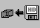
This option allows, with the same method already described in Paragraph 6.1 (valid for the selection of a Part Program), selection, in the directory C:\ECS.CNC\LAV, of the rough file which is to be graphically represented
In fact, the operator will be asked to fill in the following Data Entry:
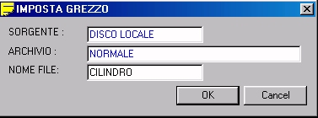
FIG. 6-14 Data Entry: "Select Rough"
If the file does not exist, the SW will assume that the operator wants to generate a rough in parallelepipedon form and will open the Data Entry shown in FIG. 6-15 necessary for introduction of the quotas on three cartesian axes. Once this phase is complete, the defined parallelepipedon will appear on the screen.

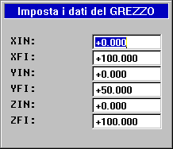
FIG. 6-15

"Rough Dimensions Setup" Data Entry

If the file already exists, but it is a generic form rough (generated by means of the editing process) it will be shown immediately.

Edit Rough
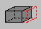
This option allows, with the same method already described in Paragraph 6.1 (valid for the selection of a Part Program), selection of the rough which is to be edited.
If the file selected was created with the help described in the previous paragraph, the operator can make changes to the dimensions by acting on the Data Entry illustrated in FIG. 6-13. If the selected file corresponds to a generic shaped rough (generated through the editing process) a notice will be given that it is impossible to make changes due to incompatibility of the format.

Cancel Rough

This selection allows any and all of the roughs present on the screen to be deleted.

Cancel Rough File

This selection allows one or more Rough Files (characterised by the extension .GRZ) from among those present in the directory C:\ECS.CNC\LAV on the Local Hard Disk (or Remote Hard Disk if the network option is present) to be deleted in a guided way.
In fact, the operator will be asked to fill in the Data Entry illustrated in FIG. 6-16.
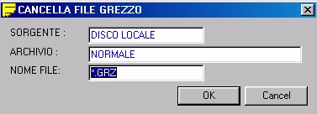
FIG. 6-16
Data Entry: "Cancel Rough File"
Press the [↓] button in the "FILE NAME" field to scroll through the list of Rough files present in the C:\ECS.CNC\LAV directory which are active and then use the [SPACE] key to alternatively select/deselect the files which are to be deleted. Use the [ENTER] key to execute the final command.

Select Variables
This allows a group of up to 5 R variables to be defined, the value of which can be viewed in real time during execution of the Part Program (for more details see Paragraph 5.10.2)

View Variables
Enable / Disable viewing of the previously selected variables with the "Select Variables" command (for more details see Paragraph 5.10.3)

Edit
This allows the user to pass over to Editing of the File which is currently in simulation. For more details on the functions of this tool, see Chapter 5 in this manual.

Cancel
Cancel the content of the Graphic Database. For more details see Paragraph 6.2.5.

Exit
Exit the Graphic Simulation Environment and return to the main menu.

GESPP

The GESPP button opens a sub-menu to manage the part program files.

Duplicate PP
The "Duplicate" sub-menu allows a File to be copied with a new name.
This operation is only permitted on the LOCAL DISK and the REMOTE DISK (if present). On LOCAL DISK exclusively on the LAV, PROGRAM archives and sub-directory PROGRAM.
Therefore it does not permit execution of operations on DISKETTE or REMOVABLE DISK and transfer of the programs between different units. In fact, the source unit must coincide with the destination unit.
In order to make file transfers between different units, the INPUT and OUTPUT commands must be utilised (for details see Paragraphs 7.7 and 7.8)
In this case, the operator will be asked to fill in the following Data Entry (FIG. 7-4):
FIG. 7- 4 Data Entry ”Duplicate File”

LAV
LAV

The rules of compilation of the Data Entry are the same as those shown in Paragraph 7.1 with the exception that in this case the SOURCE unit, once defined, coincides with the DESTINATION unit.
If the Program already exists in the DESTINATION Unit / Directory, the operator will be asked for confirmation before overwriting.

Rename PP
The sub-menu "Rename File" alows the name of a file to be changed.
The operation is permitted only on the local disk or the remote disk (if present) and exclusively on Archive LAV / PROGRAM / Sub-directory PROGRAM. In this case, obviously, once the SOURCE Unit and Archive have been defined, they will be forced as DESTINATION.
The operator will be asked to fill in the Data Entry illustrated in FIG. 7-5.

FIG. 7- 5 Data Entry “Rename File”

LAV
LAV

The rules of compilation of the Data Entry are the same as those shown in Paragraph 7.1.
If the DESTINATION Program already exists, confirmation will be asked of the operator before proceeding.

Cancel PP
The sub-menu "Delete File" allows one or more files to be deleted.
Access is permitted to all of the mass storage units available on the local disk, remote disk, DISKETTE and REMOVABLE DISK (if they exist and are connected). In case of LOCAL DISK exclusively on the LAV, PROGRAM directory and sub-directory PROGRAM.
Here the operations are also completely guided via Data Entry (FIG. 7-6).
FIG. 7-6 Data Entry “Delete File”
LAV

Once the unit on which to operate has been selected (SOURCE field), select the directory in which to operate as already described in Paragraph 7.1.
With regard to the multiple selection of several files, proceed by selecting/deselecting the files which are to be deleted using the [CTRL] + [SPACE] keys. Press the [ENTER] key to make the command definitive.
Before proceeding with the physical cancellation of File(s), the CNC will in any case ask the operator for confirmation.

Input PP
The sub-menu "INPUT" allows transfer of one or more files onto the LOCAL DISK taken from:
- REMOTE DISK (if the network option exists)
- DISKETTE (if connected)
- REMOVABLE DISK (if connected)
In particular the transfer may take place toward the LAV directory, its sub-directory WORK, PROGRAM and any of its sub-directories.
In this case it is also sufficient to fill in a Data Entry (FIG. 7-7):

FIG. 7- 7 Data Entry “Input File”
LAV

Operativity with regard to the choice of the SOURCE unit and its Archive as well as the selection of File(s) to be transferred, follow the same rules already described in Paragraph 7.1.
If the transferred Program already exists on the DESTINATION Unit / Directory, the operator will be asked to consent before overwriting. With regard to the multiple selection of several files, proceed by selecting/deselecting the files which are to be transferred using the [CTRL] + [SPACE] keys.

Output PP
The sub-menu "OUTPU" allows the transfer of one or more files from the LOCAL DISK toward:
- remote disk (if the network option exists)
- diskette (if connected)
- REMOVABLE DISK (if connected)
- A printer (if previously configured in the CNC)
In this case as well, the LOCAL DISK archive to be operated in must be defined. In fact, it is possible to select the directories: LAV (with its sub-directory WORK), TAR and PROGRAM (and any of its sub-directories)
To do this, simply fill in the Data Entry below (FIG. 7-8)
FIG. 7- 8 Data Entry: “Output File”
LAV

Operation with regard to the choice of the SOURCE unit and its Archive as well as the selection of File(s) to be transferred, follow the same rules already described in Paragraph 7.1. With regard to the multiple selection of several files, proceed by selecting/deselecting the files which are to be transferred using the [CTRL] + [SPACE] keys.
If the transferred Program already exists on the DESTINATION Unit, the operator will be asked to consent before overwriting.
If the DESTINATION has been configured as PRINTER, the printer must have been previously configured (see specific paragraph in Chapter 11) besides obviously being connected to the CNC. Note that the printer can be connected to the parallel port, the USB port, or shared over the network.

Selection of the work Directory
This selection allows organisation of the PROGRAM directory, creating new sub-directories and eliminating or renaming those which may already exist.
Pressing the button opens the window illustrated in FIG. 7-20
In this structure the following keys will be enabled:
- [↑] and [↓] to move from one sub-directory to another.
- [←] and [→] respectively to open and close the selected sub-directory.
- [Ins] to create a new sub-directory in the selected sub-directory.
- [space] to rename the selected sub-directory.
- [Del] to delete the selected sub-directory (command only operational if the sub-directory is empty).
FIG.7-20
Directory management window
PROGRAM

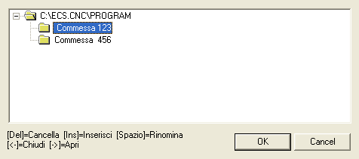
Creation of 2 sub-directories using the [Ins] key

The sub-directory which is generated will be immediately accessible as "ARCHIVES" in all of the File / Part Program Data Entry windows.

EXTERNAL EXE
Press this button to open the page where the keys to launch the external executables for the use of the customer are configured.
This functionality can be configured by editing the file \ECS.CNC\SYTEM\ExternalExecutables.ini

File Structure
The structure of the file is simplified and is planned to be integrated with the interface calibrations in the next releases.

;Launch Notepad with file name parameter
;Button Text
Note Pad
;Classname
NULL
;Executable path
C:/Windows/Notepad.exe
;Parameter
pippolino
;Launch Regedit
REG EDIT
NULL
C:/Windows/Regedit.exe
NULL
;Launch Calculator
Calc
;Classname
Calculator
;executable path
C:/Windows/System32/Calc.exe
NULL
;
MS Paint
Image - Paint
C:/Windows/System32/mspaint.exe
NULL
;

As can be easily inferred, all of the rows which begin with ";" are comments while the indication below of the 4 rows to be inserted refer to each external executable which is to be configured

The other rows contain the following information:
- 1st row Note Pad Represents the text of the button (max 5+5 characters)

- 2nd row ClassName/NULL/StringOfThe Title The class name if recognised or the string of the title of the application, otherwise NULL

- 3rd row C:/Windows/Notepad.exe the complete executable path

- 4th parameters/NULL any parameters to be sent on the command line of the executable or NULL. In this case no parameters will be inserted in the launch string

Upon start up of the system this file is read and the respective buttons are created which, when pressed, will activate the desired executable.
If the button is activated repeatedly and if the "ClassName" information was not inserted, multiple instances of the same executable could be activated.
Often the applications self-check whether they are already active, impeding the launch of a new instance.
Whoever uses the application project must take care to avoid multiple launches.
Furthermore, the launched applications are not closed automatically with the request for closing from the CNC because the operator must take care of closing any applications launched by saving the work in progress.

JOB INFO
Pressing this button opens a new menu in which three types of information regarding the work in progress can be selected.

FORFLA, FORFLA, WRITE (Macro)

FORFLA Button. This selection is significant only in the event that the program in execution contains a "FORFLA" macro (relative to making holes on a circular flange) or a "FORMAT" macro (utilised to make holes arranged on a straight line or in the nodes of a matrix) or a "WRITE" macro (utilised to engrave a string of characters).Pressing the button will command a window to open which contains data congruent with the last macro performed of this type.

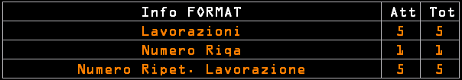

OVERMETAL
The OVER METAL button activates the view of the information regarding the active overmetal both on the profile and on the cutting depth.

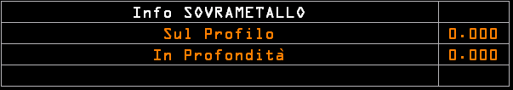

CONTOURING (Contouring Plane)

The CONTOURING button activates the view of the information regarding the contouring plane.This window, which occupies the area normally utilised for viewing the "Distance" left to travel, shows the following data:
- The programmed contouring plane (for example XY).
- The coordinates of the final point programmed or calculated by the GAP or EXPERT in case of linear interpolation (G01).
- The coordinates of the programmed final point and the coordinates of the centre programmed or calculated by the GAP or EXPERT in case of linear interpolation (G02 or G03).

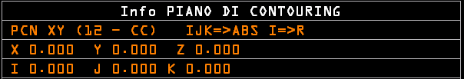

Info:
This window can be moved and positioned anywhere on the screen by using an external three button mouse, clicking on the centre button.
The window will change its look turning grey and may be moved anywhere on the screen by clicking it with the left mouse button and with the cursor positioned anywhere on the window.
Once positioned, the system will remember the location and the next time it is viewed it will open up to the exact same place.
The window can be moved at any time from its current position to the original position by right-clicking with the mouse on the selected window.

SETUP environment
This environment contains all of those procedures which allow the machine to be configured and customised as well as a series of utilities both for the operator and the manufacturer.

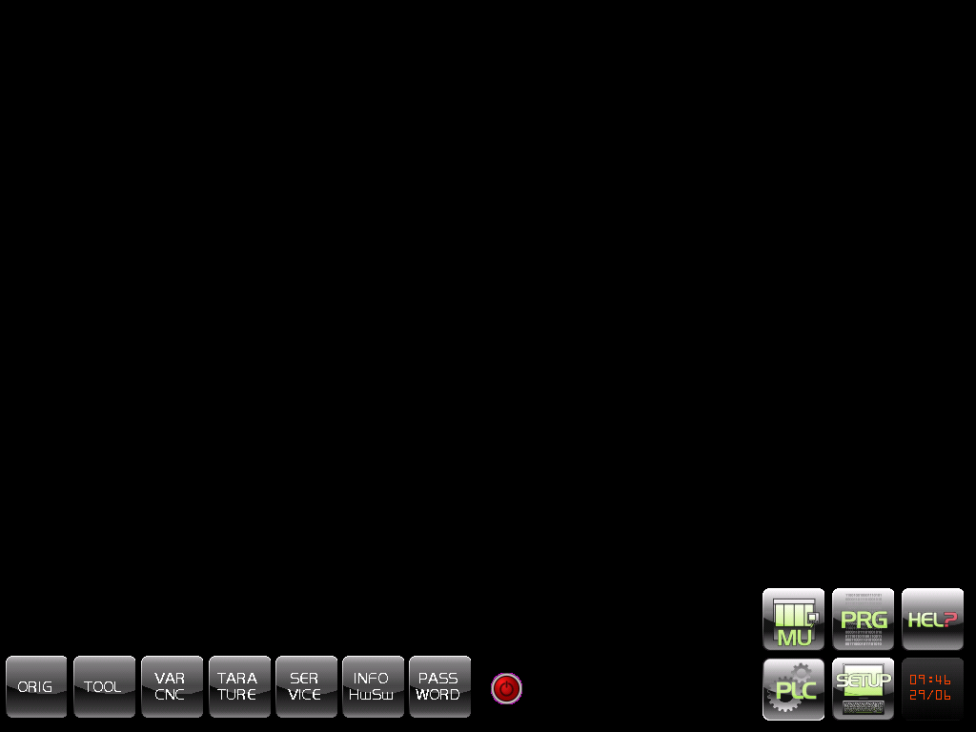

The menu which is shown when entering this environment is as follows:



ORIG Origins Management

TOOL Tool Management

VAR CNC Viewing of CNC Variables

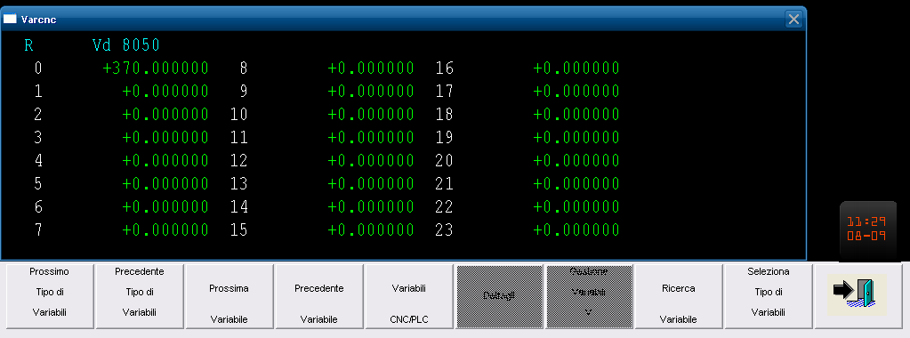

CALIBRATION (CNC Calibration)

The CNC ECS 900 Series can be configured essentially by means of two distinct mechanisms:
- The Calibration Files
- The Sub-programs dedicated to Specific Functions.
While the first are described in detail in the "CNC 900 Series CALIBRATION MANUAL" with code 720P385, for the second, see the "Advanced Programming" manual, code 720P396.
Both the Calibration Files and the specific use Sub-programs can be accessed exclusively from the Setup Environment by selecting the CALIBRATION button.
Remember that this environment, for security reasons, is protected by Password and that, in order to insert the Password, the "Manufacturer" or "ECS" level password must be inserted.

Edit Config Files
The parameters contained in these files are acquired before passing to the EXE state of the PLC.
Some of these parameters can be run-time modified both from Part Program and from PLC.
The Configuration Files reside in the C:\ECS.CNC\TAR directory and are editable by selecting the "Edit Config Files" button.
Any changes are activated by means of the "Update Calibrations" command (also accessible from the CALIBRATION menu) or by turning the CNC off and back on.
Modifying these files means replacing the values, predominately numeric, associated with the various fields therein.
The following table shows the list of the available Calibration Files:
FILE NAME | FUNCTION
SWCNF.TAR | CNC HW Configuration.
AXS.TAR | Configuration of the chuck and axes parameters.
CANCNF.BIN (***) | Data inherent to the configuring CAN OPEN modules (do not modify).
COR.TAR | Axes error correction.
COREMECS.TAR | Teach Pendant Schleicher settings
CUMAG.TAB | Configuration of the tools magazine.
TYPCU.TAB | Definition of the type of tool change.
FA.TAB | Definition of the F.A. associated with the sub-program.
GEN.TAR | Various calibrations of the CNC.
GFN.TAB | Definition of G functions.
MACROECS.TAR | Definition of Macro attributes (i.e. MACRO.TAR).
MISC.TIM | Definition of the execution time associated with the various F.A.
VIDAX.TAR | Definition of the axes to view in graphic environment.
SPC.TAR | Any RTCP head configuration.
NETPATH.TAR | Setup of the remote work directory (with network active).
TT.BIN | CNC environment tools file (binary file - do not modify)
VT.BIN | Video-graphic environment tools file (binary file - do not modify)
ORGA.TAB | CNC origins ambient table (do not modify).
VORG.TAB | Video-graphic origins ambient table (do not modify).
XCPANEL.CMD | File utilised for Windows Control Panel management (do not modify).
CPY.TAB (*) | Default configuration parameters for copying.
DGTZ.TAR (*) | Graphic digitalisation environment configuration.
V.BAT (**) | Definition of the variables utilised by the Interface SW and by the CNC.
(*) These files are described in detail in the "Digitalisation Option" Manual, Code 720P402
(**) This file, although containing general use settings, is not located in the C:\ECS.CNC\TAR directory and differs structurally somewhat from the previous files.
(***) Binary file constructed by means of a specific application (CANMGR) available in PLC development environment.

The Sub-programs dedicated to Specific Functions
These files, utilised to realise the axes zero point, manage the tool change, re-initialise the default parameters at the beginning of a Part Program, etc, are written in ISO and ECS LIP language and therefore follow the same programming rules as a work program (for details see the Programming Manual and Advanced LIP Programming).
Modifying these files means acting on the parameters written in numbered records, or adding one or more record at the end of it, maintaining a progressive numbering record.
These sub-programs are executed by the CNC only at the moment in which they are recalled by the corresponding function. Any modification, if not specified differently in the description, is activated reprogramming the functions which recalls the sub-program.
These files reside in the C:\ECS.CNC\LAV\MACRO directory and are therefore not visible to the operator (who only accesses the contents of C:\ECS.CNC\LAV) and they can be modified by selecting the "Modify Sub-program" button.

The table below shows the list of the Sub-programs dedicated to specific functions:
FILE NAME | FUNCTION
COST | Parameters utilised by the CNC and predispositions to be activated on start up.
TOOL | Operational cycle of the Auxiliary T function.
DCOR | Operational cycle of the Auxiliary D function (tool corrector).
CUA | Predisposition and operational cycle of the automatic tool change.
CUA.SUB | Operational cycle of the automatic tool change in the event that it is managed entirely by a Subroutine (like in the case of a rack C.U.).
CUM | Predisposition and operational cycle of the manual tool change.
CUM.SUB | Operational cycle of the manual tool change in the event that it is managed entirely by a Subroutine.
G8xx | Elementary function implemented at CNC level and utilised in the Set of Linear axes.
G9xx | Elementary function implemented at CNC level and utilised in the Set of Round axes.
SETxx | Operational zero point cycle of the corresponding axis.
SETAL | Operational zero point cycle for all axes.
RIGABS | Operational zero point cycle for encoded optical row.
ENCABST | Operational zero point cycle for encoded optical encoder applied to round axis (for example a rotating table).
ENCABSL | Operational zero point cycle for encoded optical encoder applied to linear axis (for example a screw).
SECFA | Operational cycle of the second auxiliary function (default H).
THIFA | Operational cycle of the third auxiliary function (default E).
RESET | Operational cycle recalled by the button of the same name on the keyboard.
M02 /M30 | "Closure" Part Program Sub-programs
M10 | Operational cycle of the F.A. subroutine of the same name utilised to manage the locking of the mechanically conditioned (lockable) axes.
M11 | Operational cycle of the F.A. subroutine of the same name utilised to manage the unlocking of the mechanically conditioned (lockable) axes.
SALVA / RIPRIS | These allow saving an restoring of the current conditions of the CNC (Length compensation, Specularity, Matrix, etc.)
ERROR | Sub-program utilised to send the CNC into alarm condition viewing a specific message.

Any errors detected by the CNC during the processing phase of a file are recorded in the ERR.CNC file, viewed automatically on the display in case of error.
The possible errors detected are:
Errors in files: the name of the file in which the error was detected is written in ERR.CNC.
Errors in records: the content of the record without spaces and comments, up to the incorrect parameter and the error code are written in ERR.CNC.
In this case greater details can be accessed through the selection in "Help Environment" of the button for viewing the text of a "TEXT ALR" alarm, therefore writing the relative alarm code and pressing the "OK" button.
The CNC verifies the content of the configuration files only after passage of an ALT →EXE stage or following an "Update Calibration" command.
The CNC passes into EXE status only if the Calibration Files are correct.
The diagnostic relative to the Sub-program is, on the other hand, activated only when they are recalled by the corresponding function.

Various Utility SERVICE

BACKUP
This selection launches a guided procedure which allows saving the following files:
• ECS provided files residing in C:\ECS.CNC\LAV\MACRO which have been modified.
• All of the files residing in C:\ECS.CNC\LAV\MACRO not provided byECS.
• All of the files residing in C:\ECS.CNC\TAR provided by ECS which have been modified.
• All of the *.C, *.MU, *.INC files residing in C:\ECS.CNC\SWPLC\WRK.
• All of the customisation files which have been modified (for example the files associated with
viewing windows, those necessary to build the PLC button menus, the calibrations of any EC drives,
the configurations and data captured with the logical analyser instrument, etc.).
The complete list of the files which will be saved is accessible, in any case, viewing the content of the
DOWNLOAD.LST file located in C:\ECS.CNC\SYSTEM.
Never modify this file!
Saving can be done on a 3.5" 1.44MB diskette or on a removable disk, if present, which
must in any case be pre-formatted. It is possible in any case to select, utilising the
standard Windows navigation method, any local or network unit and directory.
Saving also includes the data currently present in the Dual Port of the CNC (that is the area of
inter-exchange memory between the PC and CPU Real Time).

RESTORE
This selection, active exclusively with CNC in HALT, commands the appearance on the screen of the menu
illustrated in FIG. 4-1 where it is possible to:

Enable the SW options contained in the "Options" diskette. Select "Load Options from Floppy Disk"
– “Load Options from Floppy Disk” /
• View / modify the CNC SW options. Select “Enable Options” – “ Options Setting”
This is possible by acting on a "10 box form" (see FIG. 4.2) each containing
16 boxes associated with as many options. The option is active (or is desired to be so) if the
corresponding box is "ticked". In the structure, move around as usual with the
[TAB] button. A box can instead by selected / deselected alternatively pressing the
[SPACE] key. A summary description of the options is provided in a special field placed in the
lower part of the window.

Remember that unlocking new options is strictly correlated with the order number of the
CNC, and the key that ECS provides together with the options themselves. It is therefore not possible
to unlock options without having the relative key, nor to transfer them from a CNC to
another due to the different Order number. The “Enable Options” - “Options
Setting" selection shows, among other things, the Order number and the CNC key (associated with the
currently enabled options).
• Load the files in the CNC which were appropriately saved on a Floppy Disk, a removable disk or a
local or network unit/directory. This procedure is utilised, for example, to load
a project in the CNC which was realised with the Resource Builder, PLC MENU, MacroMenuDev tools or a configuration of the CAN Open modules realised with CAN Manager. Remember that in the
WIN Series CNC restoration of the tool table configuration previously saved with the
"DUMP" procedure (for details see the "Standards for Use manual for CUTTER code 720P392, for
LATHE code 720P409) always takes place this way.
• Load the data saved with the Backup procedure described in the previous paragraph into the CNC.

CANC TEMP (Cancel temporary files)
This selection allows deletion of all the files created by the system automatically, but which can be deleted without compromising operation of the system.
There are two types of these files:
- temporary files
- ID files

These files can be chosen selectively for deletion with the following selection.

DEL TMP (Delete all files)
Delete all of the files in the "/ECS.CNC/TMP" folder after confirmation by the operator.

DEL ID (Delete all IDFiles)
Delete all of the files in the "/ECS.CNC/IDFILE" folder after confirmation by the operator.

STATISTICS
Feature currently under development.

CHANGE LANGUAGE
by pressing the button the language selection menu appears.

The languages available for selection are:
- Italian
- English
- French
- Spanish
- German
- Custom (optional language)

By selecting one of the possible languages, the program will restart automatically in order to activate the messages in the new language.
With regard to the configuration in the "Custom" language, this is generally configured and tested each time in relation to the user's needs.

VEDDCOM
The application launched with this button has to do with the management of the ECS activations, therefore see the relative documentation.INFO HWSW Information on the CNC hardware and software

INFO HW

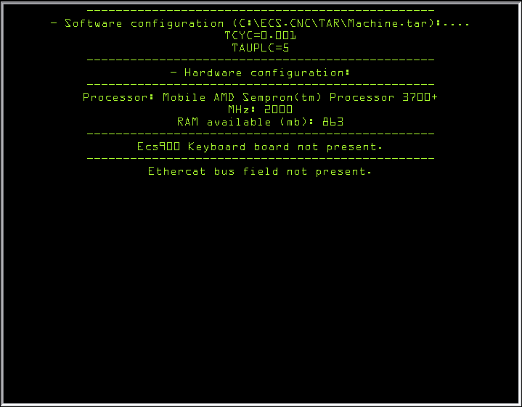

INFO HW

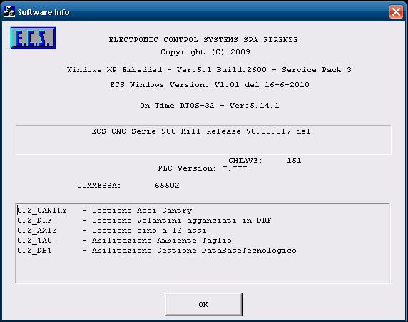

PASSWORD password management

Management of the password is completely renewed compared to the past.
There are many passwords now depending on the access level which is to be given to the operator or the user. The password levels are as follows:

- Manufacturer Level
- User Level
- Operator Level 10
- Operator Level 9
- Operator Level 8
- Operator Level 7
- Operator Level 6
- Operator Level 5
- Operator Level 4
- Operator Level 3
- Operator Level 2
- Operator Level 1

Naturally the highest level, Manufacturer Level, is the one which has the most privileges and can modify practically all of the CNC parameters.
As the level decreases, the privileges decrease and therefore less and less parameters can be modified.
Management of the operator passwords is slightly different in that these can be attributed any level from 1 to 10 and, although still a lower level compared to the first two, this feature allows different privileges to be attributed depending on the skills and/or capabilities of each single operator.
The PLC is responsible for attributing privileges.

For your information, there is also an ECS password, but it is not documented in this manual. This password allows access to the areas of the CNC in a complete way.
All of the passwords are case sensitive, therefore the upper-case/lower-case must be observed and both numbers and letters are accepted.

INS PSW (Insert password)
This button opens the data entry relative to password input. The system verifies the correspondence with one of the memorised passwords and consequently sets the new access level for the entire CNC.

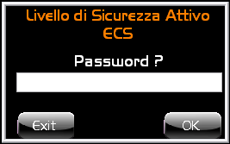

MOD PSW (Modify password)
Press this button to view the window shown below which allows the passwords of all the levels which have lower privileges than that currently active can be viewed.
By inserting a password with lower privileges, all of the password strings viewed with higher privileges will be concealed by asterisks.
This feature is useful in order to manage all of the passwords with lower privileges.

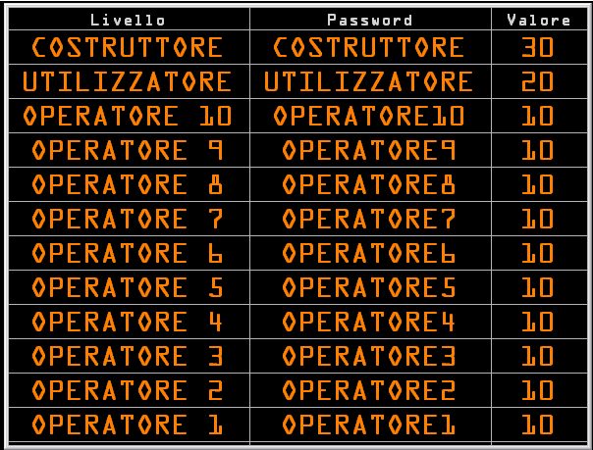

By clicking on a password string the data entry is opened in which we can modify the corresponding password.
Besides the field for insertion of the new password in the data entry, there is also a drop-down box with values from 1 to 10 which is used to define the protection level for the Operator password.
As mentioned previously, the PLC is responsible for selecting the privileges.

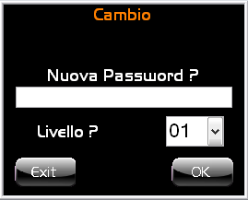

Power Off (Shut down)
This button allows the CNC, PLC software to be terminated and therefore the machine on which it is installed to be shut down.

By utilising this button, all of the applications will be correctly closed without loss of data or endangering the system. Therefore, we recommend always utilising this button before turning off the machine.

HELP Environment

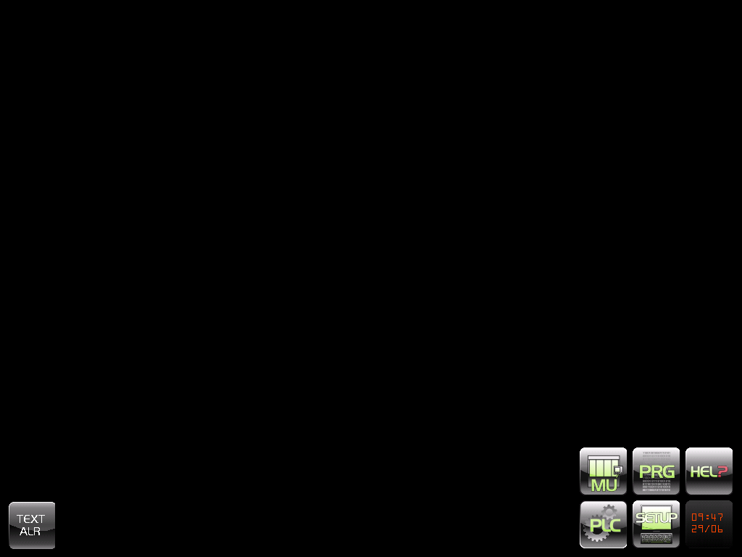

Viewing an alarm text

By clicking on the "TEXT ALR" button a view will open which requires an alarm code to be inserted and with the next pressing of the OK button the requested text will be viewed.

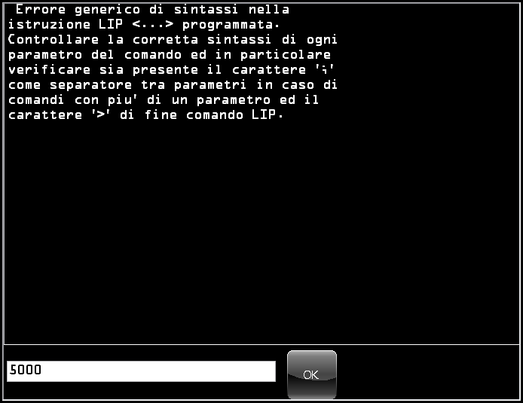

In the event that the alarm code which was inserted does not correspond to a text, no text will be displayed.

It is still possible to close the view by simply clicking on the "TEXT ALR" button

CLOCK

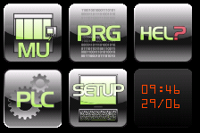

Although the date and time view is not a true and proper button, clicking it will allow the Environment menu to be viewed or hidden.
This feature is necessary to view the buttons which are at the bottom in some of the older applications.
The date and time are those of the system and can be modified only through the Windows XP functions.

Password insertion
By setting the "focus" on this button and simultaneously pressing the [CTRL]+[SHIFT]+F2 buttons the data entry for insertion of the password will be opened. By inserting a valid password modification of the system access level is obtained.

User's notes
Index

User's notes; 2-105

